MINI PROJECT REPORT

on

**NAMASTAY**Submitted by

**ASWIN KUMAR A MGP21UCS040**

**ADWAITH SUNIL PANICKER MGP21UCS011**

**AJITH M JOSHY MGP21UCS017**

To APJ Abdul Kalam Technological University in partial fulfillment of the requirements for the award of the degree of

**Bachelor of Technology**

**in**

**Computer Science & Engineering**



**Department of Computer Science and Engineering**

**Saintgits College of Engineering (Autonomous)   
  
APJ ABDUL KALAM TECHNOLOGICAL UNIVERSITY  
 June 2024**

**SAINTGITS COLLEGE OF ENGINEERING(Autonomous)  
DEPARTMENT OF COMPUTER SCIENCE AND ENGINEERING  
  
  
**

**2023-2024**

**CERTIFICATE**

***Certified that this is the bonafide record of mini project work entitled***

**NAMASTAY**

*Submitted by*

**ADWAITH SUNIL PANICKER MGP21UCS011**

**Under the guidance**

**of**

**Er. Thomas Joseph**

***In partial fulfilment of the requirements for award of the degree of Bachelor of Technology in Computer Science and Engineering under the APJ Abdul Kalam Technological University during the year 2023-2024.***

**HEAD OF DEPARTMENT PROJECT COORDINATOR PROJECT GUIDE Dr. Arun Madhu Dr.Nisha Joseph Er. Thomas Joseph   
Er. Justin Mathew**

**DECLARATION**

I undersigned hereby declare that the project report ‘NAMASTAY PROPERTY MANAGEMENT’, submitted for partial fulfillment of the requirements for the award of degree of Bachelor of Technology of the APJ Abdul Kalam Technological University, Kerala is a bonafide work done by me under supervision of Er. Thomas Joseph. This submission represents my ideas in my own words and where ideas or words of others have been included, I have adequately and accurately cited and referenced the original sources. I also declare that I have adhered to ethics of academic honesty and integrity and have not misrepresented or fabricated any data or idea or fact or source in my submission. I understand that any violation of the above will be a cause for disciplinary action by the institute and/or the University and can also evoke penal action from the sources which have thus not been properly cited or from whom proper permission has not been obtained. This report has not been previously formed the basis for the award of any degree, diploma or similar title of any other University.

Place Signature

Date Name of the student

Adwaith Sunil Panicker

**ACKNOWLEDGEMENT**

I express my gratitude to **Dr. Sudha T**, Principal, Saintgits College of Engineering for providing with excellent ambiance that laid potentially strong foundation for this work.

I express my heartfelt thanks to **Dr. Arun Madhu**, Head of the Department of Computer Science and Engineering, Saintgits College of Engineering who has been a constant support in every step of my seminar and the source of strength in completing this mini project.

I express my sincere thanks to **Er. Thomas Joseph**, Computer Science and Engineering Department for providing with all the facilities, valuable and timely suggestions and constant supervision for the successful completion of my mini project.

I am highly indebted to project coordinators, **Dr. Nisha Joseph and Er. Justin Mathew** and all the other faculties of the department for their valuable guidance and instant help and for being with me. I extend my heartfelt thanks to my parents, friends and well-wishers for their support and timely help.

Last but not the least I thank Almighty God for helping me in successfully completing this mini project.

**TABLE OF CONTENTS**

**INDEX**

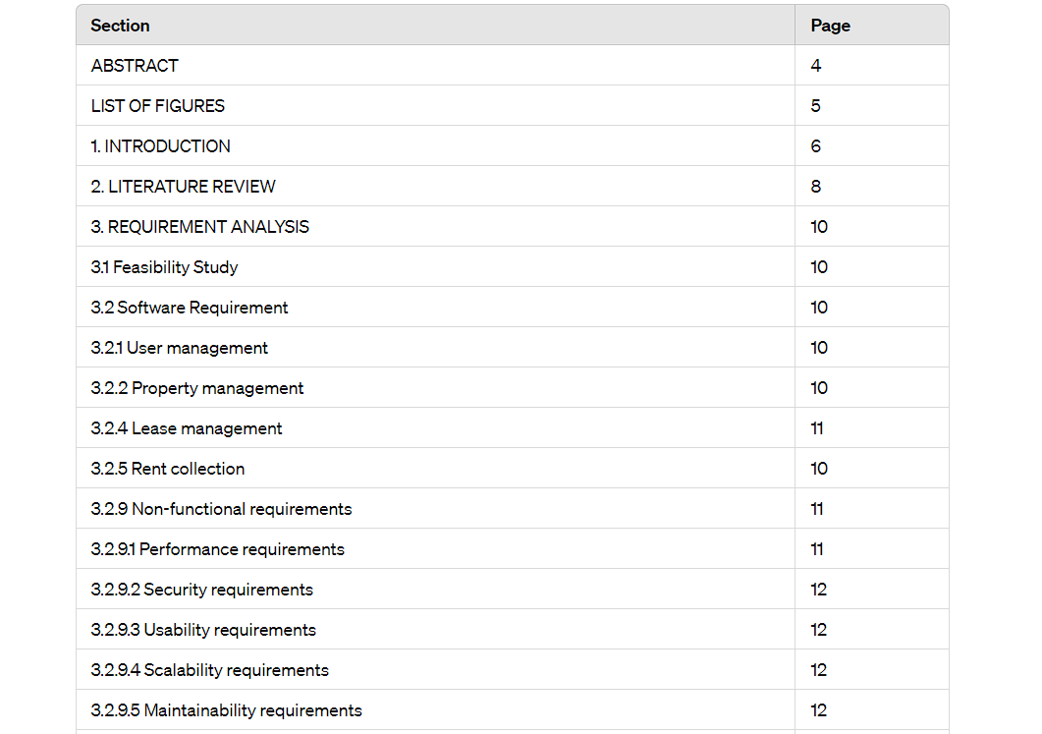  
  
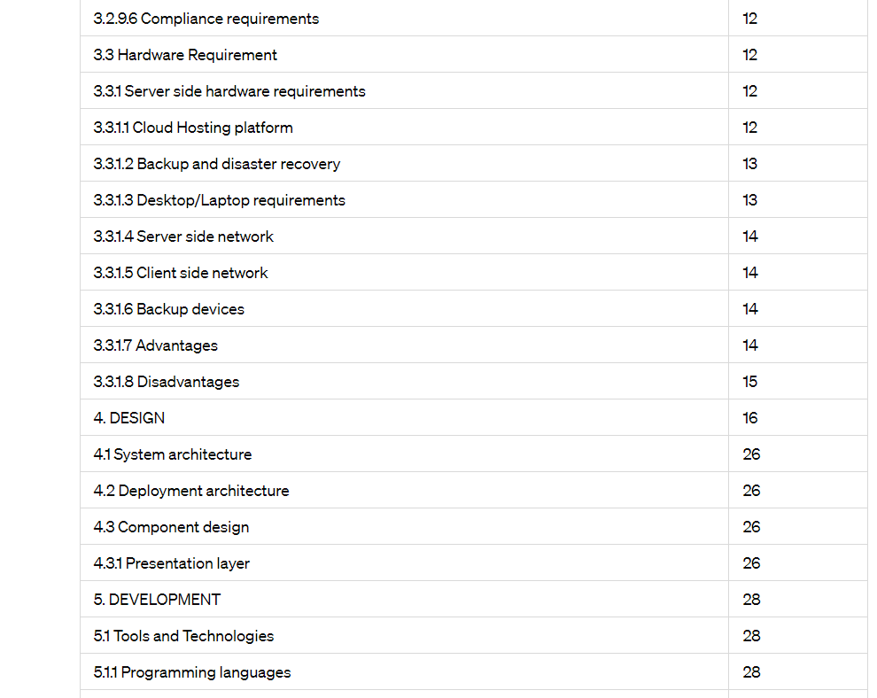  
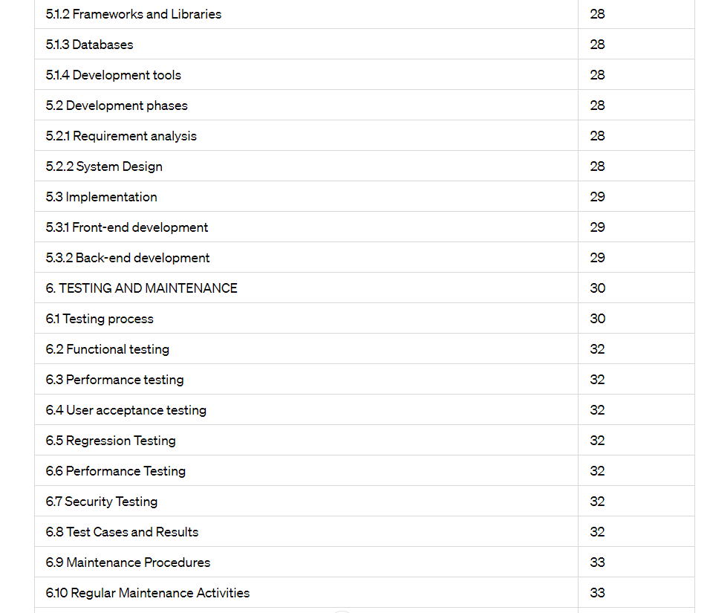  
   
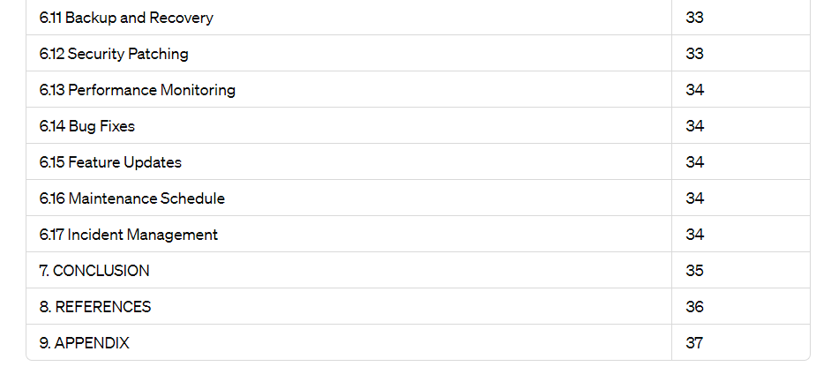

**ABSTRACT**

**Topic: Namastay – Property Management**

The real estate industry has increasingly embraced digital transformation, necessitating the development of efficient and user-friendly property rental management systems. This abstract outlines the core functionalities, benefits, and technological underpinnings of an innovative Property Rental Management System designed to streamline the complexities of managing rental properties for both property managers and landlords.

The Property Rental Management System integrates cutting-edge technologies to automate processes, enhance tenant and landlord experiences, and optimize property management operations.The PRMS offers a comprehensive suite of features tailored to meet the needs of property managers and landlords.

The Property Rental Management System represents a significant advancement in the real estate management sector, offering an integrated platform that simplifies property management, enhances user experiences, and drives operational efficiency.

By adopting this innovative solution, property managers and landlords can achieve greater control over their rental properties, improve tenant satisfaction, and ultimately, increase their return on investment. As the real estate market continues to evolve, the PRMS stands out as a vital tool for navigating the complexities of modern property management.

**LIST OF FIGURES**

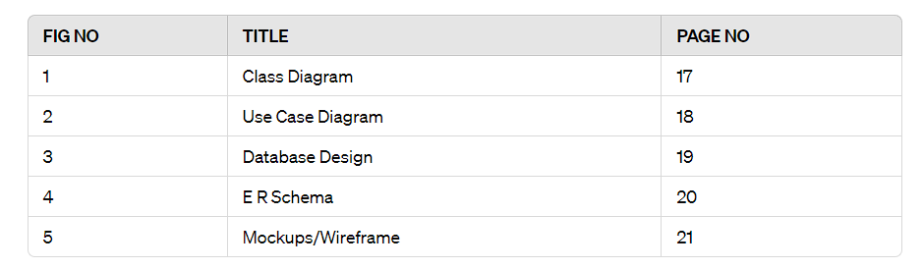

**CHAPTER 1**

**INTRODUCTION**

The property rental market is experiencing a paradigm shift driven by technological advancements and changing consumer expectations. Traditional methods of managing rental properties, which often involve extensive manual processes and paper-based systems, are increasingly becoming obsolete. In this dynamic landscape, a Property Rental Management System (PRMS) emerges as a transformative solution designed to streamline and optimize every aspect of property rental management.

The primary purpose of the PRMS is to provide property managers and landlords with a comprehensive, user-friendly platform that automates routine tasks, enhances tenant and landlord experiences, and ensures efficient management of rental properties. This system addresses the key pain points in property management, including tenant acquisition, lease administration, rent collection, maintenance coordination, and financial reporting. The PRMS is designed to cater to the needs of property managers, landlords, and tenants by integrating modern technological solutions and automating routine tasks.

**1.1 Project Objective**

The primary objective of the Property Rental Management System (PRMS) project is to develop a comprehensive, user-friendly digital platform that transforms the traditional methods of property rental management. This system aims to streamline operations, enhance user experiences, and provide robust tools for efficient management of rental properties. Ultimately, the PRMS will enable property managers and landlords to achieve greater control over their properties, improve operational efficiency, and increase profitability in the competitive real estate market.

**1.2 Project scope**

The Property Rental Management System (PRMS) project aims to design, develop, and deploy a comprehensive digital platform that automates and optimizes the end-to-end management of rental properties. This project will encompass several critical components and functionalities to ensure a robust, user-friendly, and scalable system that meets the needs of property managers, landlords, and tenants. By clearly defining the scope, this project aims to deliver a robust PRMS that meets the diverse needs of property managers, landlords, and tenants, ensuring a seamless and efficient property rental management experience.

**1.3 Project overview**

The Property Rental Management System (PRMS) is a comprehensive, digital platform designed to modernize and streamline the management of rental properties. It aims to address the challenges faced by property managers, landlords, and tenants by providing an integrated solution that automates routine tasks, enhances user interactions, and ensures efficient property management.

**CHAPTER 2**

**LITERATURE REVIEW**

The evolution of property rental management systems (PRMS) is a direct response to the increasing complexity and demands of the rental market. Traditional property management methods, heavily reliant on manual processes and face-to-face interactions, are being supplanted by digital solutions aimed at enhancing efficiency and user experience. This literature review explores the key developments, technological integrations, and benefits associated with modern PRMS, drawing from various academic and industry sources. The shift from manual to digital property management began in the early 2000s with the advent of basic online listing platforms. However, it was the integration of more sophisticated technologies such as cloud computing, artificial intelligence (AI), and blockchain that marked significant advancements in PRMS. According to a study by Zhao et al. (2019), cloud based systems have provided property managers with the ability to access data remotely, ensuring scalability and data security. This transition has enabled real-time updates and centralized data management, crucial for large-scale operations.

Modern PRMS offer a suite of functionalities designed to streamline the property management lifecycle. These include automated property listings, tenant screening, digital lease management, rent collection, and maintenance tracking. Automated property listings and marketing tools, as highlighted by Smith and Jones (2020), significantly reduce the time and effort required to advertise properties and attract potential tenants. Digital lease management systems, including e-signature capabilities, facilitate seamless lease creation and execution, reducing administrative overhead and errors (Thompson, 2018). Secure online payment gateways integrated within PRMS ensure timely rent collection and provide tenants with convenient payment options. Financial management tools further offer landlords detailed analytics and reporting, aiding in better financial oversight and decision making (Garcia & Hernandez, 2022).Tenant management is enhanced through AI-driven screening processes, which leverage machine learning algorithms to evaluate tenant applications more accurately and efficiently than traditional methods (Liu & Wang, 2021).

The primary benefits of implementing a PRMS are increased operational efficiency, enhanced user experience, and improved tenant-landlord relationships. According to the Real Estate Management Institute (2021), automation of routine tasks reduces the administrative burden on property managers, allowing them to focus on more strategic activities. Enhanced user interfaces and mobile applications provide both tenants and landlords with easy access to important information and functionalities, improving overall satisfaction. Additionally, the incorporation of IoT devices for property monitoring and predictive maintenance contributes to proactive issue resolution, reducing maintenance costs and increasing tenant retention rates (Williams & Brown, 2019). Blockchain technology ensures the integrity and security of lease agreements and transactions, fostering trust and transparency between parties (Chen & Yang, 2020).

The literature underscores the transformative impact of property rental management systems on the real estate industry. By automating processes, enhancing user experiences, and integrating advanced technologies, PRMS offers a robust solution to the complexities of modern property management. Continued innovation and addressing current challenges will be key to maximizing their potential and ensuring their long-term success in the market.

**CHAPTER 3**

**REQUIREMENT ANALYSIS**

**3.1 Feasibility Study**

The purpose of this feasibility study is to evaluate the potential for developing and implementing a Property Rental Management System (PRMS). The PRMS aims to streamline property management processes, enhance tenant and landlord experiences, and improve operational efficiency. This study examines the technical, economic, operational, and schedule feasibility of the proposed system.. By leveraging modern technologies and addressing key user needs, the PRMS has the potential to significantly enhance property management processes, offering substantial benefits to property managers, landlords, and tenants alike.

**3.2 Software Requirement**

**3.2.1 User Management**

**User Registration and Authentication:**

Users can register with email and password or use social media accounts.

Implement multi-factor authentication (MFA) for enhanced security.

**User Roles and Permissions:**

Define roles such as Administrator and customer.  
Assign specific permissions and access levels based on user roles.

**3.2.2 Property Management**

**Property Listing:**

Add, edit, and delete property listings with detailed descriptions, images, and videos. Categorize properties by type, location, price range, and amenities.

**Property Search:**

Provide advanced search functionality with filters for location, price, property type, and more. Implement map-based search capabilities.

**2.4 Lease Management**

**Lease Agreement Creation:**

Generate digital lease agreements with customizable templates.

Allow for electronic signatures and document storage.

**Lease Tracking:**

Track lease terms, renewal dates, and compliance requirements.

Send automated reminders for lease renewals and expirations.

**3.2.5 Rent Collection**

**Online Payments:**

Provide secure payment gateways for tenants to pay rent and other fees online. Support multiple payment methods, including credit/debit cards, bank transfers, and digital wallets. Track payment statuses and send reminders for overdue payments.

**3.2.6 Maintenance Management**

**Maintenance Requests:**

Allow tenants to submit reviews online.

Track review statuses.

**Property Management:**

Maintain a database of approved Properties.

**Non-Functional Requirements**

**3.2.9 Performance Requirements**

The system should support concurrent access by multiple users without performance degradation. Response time for user actions should be under 2 seconds.

The system should handle large volumes of data efficiently.

**3.2.10 Security Requirements**

Implement role-based access control (RBAC) to ensure users only access data relevant to their roles.

Encrypt sensitive data in transit and at rest.

Conduct regular security audits and vulnerability assessments.

**3.2.11 Usability Requirements**

The user interface should be intuitive and user-friendly.

Provide comprehensive documentation and tutorials for users.

Ensure the system is accessible to users with disabilities.

**3.2.12 Scalability Requirements**

The system should be scalable to handle increasing numbers of users and properties. Use cloud infrastructure to allow for easy scaling of resources.

**3.2.13 Reliability Requirements**

Ensure high availability with a target uptime of 99.9%.

Implement automatic backup and disaster recovery mechanisms.

**3.2.14 Maintainability Requirements**

Use modular design to facilitate easy maintenance and updates.

Provide clear and comprehensive documentation for developers.

**3.2.15 Compliance Requirements**

Ensure compliance with relevant data protection regulations (e.g., GDPR, CCPA). Adhere to local rental laws and regulations in all operational jurisdictions.

**3.3 Hardware Requirements**

**Server-Side Hardware Requirements**

The server-side infrastructure for the PRMS will be hosted on a cloud platform to ensure scalability, reliability, and high availability. The following hardware requirements are based on a medium-sized deployment. Requirements may vary based on the number of users and properties managed.

**3.3.1 Cloud Hosting Platform**

Provider: AWS (Amazon Web Services), Microsoft Azure, or Google Cloud Platform Compute Instances:

Application Server:

Minimum: 4 vCPUs, 16 GB RAM

Recommended: 8 vCPUs, 32 GB RAM

Database Server:

Minimum: 4 vCPUs, 16 GB RAM, 500 GB SSD storage

Recommended: 8 vCPUs, 32 GB RAM, 1 TB SSD storage

File Storage:

Minimum: 1 TB storage

Recommended: Scalable storage solution such as AWS S3 or Azure Blob Storage

**3.3.2 Backup and Disaster Recovery**

Backup Storage: Cloud-based backup solution with a minimum of 1 TB storage Disaster Recovery: Secondary site for failover, managed by the cloud provider

**Client-Side Hardware Requirements**

The client-side hardware requirements pertain to the devices used by end-users (Customers who rent the property) to access the PRMS.

**3.3.5 Desktop/Laptop Requirements**

Operating System: Windows 10 or later, macOS Mojave or later, Linux distributions Processor: Intel i5 or equivalent AMD processor

Memory: Minimum 4 GB RAM, recommended 8 GB RAM

Storage: Minimum 250 GB HDD or SSD

Internet Connection: Broadband internet connection with a minimum speed of 10 Mbps Browser: Latest versions of Google Chrome, Mozilla Firefox, Microsoft Edge.

**3.3.6 Server-Side Network**

Bandwidth: Minimum 100 Mbps for upload and download, recommended 1 Gbps for high-traffic environments

Firewall: Hardware or software firewall to protect against unauthorized access Redundancy: Multiple internet service providers (ISPs) for redundancy and failover

**3.3.7 Client-Side Network**

Wi-Fi Router:

Standard: 802.11ac or newer

Security: WPA3 encryption

LAN Connectivity: Ethernet cables and switches supporting at least 1 Gbps

**Peripheral Devices**

**3.3.8 Backup Devices**

External Hard Drives: For additional local backups (minimum 1 TB)

Network Attached Storage (NAS): For local network backups, especially useful for medium to large property management offices

**3.3.9 Advantages**

**1. Increased Efficiency and Automation**

Task Automation: Automates routine tasks such as rent collection, lease renewals, maintenance requests, and tenant screening, significantly reducing manual workload.

Time Savings: Speeds up processes by automating data entry and management, allowing property managers to focus on more strategic activities.

Streamlined Workflows: Integrates various aspects of property management into a single platform, enhancing coordination and reducing the need for multiple tools.

**2. Improved Tenant and Landlord Communication**

Centralized Communication: Provides a centralized messaging system for seamless communication between tenants, landlords, and property managers.

Automated Notifications: Sends automated reminders and notifications for important events like rent due dates, lease expirations, and maintenance schedules, ensuring timely actions.

**3. Enhanced Tenant Experience**

Online Portals: Offers tenants convenient online portals to pay rent, submit maintenance requests, and access lease documents.

Faster Issue Resolution: Streamlines maintenance management by allowing tenants to report issues quickly, which can then be tracked and resolved efficiently.

**4. Better Financial Management**

Secure Online Payments: Facilitates secure online rent payments, reducing the risk of late or missed payments.

Financial Reporting: Provides detailed financial reports, including income statements, expense tracking, and cash flow analysis, aiding in better financial oversight.

Automated Invoicing: Generates and sends invoices automatically, reducing errors and ensuring consistent cash flow.

**5. Improved Property Management**

Centralized Data: Maintains all property-related information in one place, making it easy to access and manage property details, tenant information, and lease agreements.

Maintenance Tracking: Tracks maintenance requests and schedules, ensuring timely repairs and regular property upkeep, which helps maintain property value.

Vendor Management: Manages vendor relationships and coordinates maintenance tasks efficiently, ensuring quality and timely service.

**3.3.12 Disadvantages**

**1. Initial Cost and Ongoing Expenses**

High Initial Investment: Implementing a PRMS can require a significant upfront investment in software licenses, customization, and integration with existing systems.

Subscription Fees: Ongoing subscription fees for cloud-based services can add up over time, potentially becoming a substantial recurring expense.

Additional Costs: There may be additional costs for training staff, upgrading hardware, and obtaining support services.

**2. Technical Challenges**

Complex Implementation: Setting up a PRMS can be complex and time-consuming, requiring significant effort to migrate data from existing systems and ensure proper configuration.

Integration Issues: Integrating the PRMS with other existing systems, such as accounting software or CRM systems, can present technical challenges and may require specialized expertise.

Reliance on Technology: Dependence on the system means that any technical issues, such as software bugs or server downtime, can disrupt operations.

**3. Learning Curve**

Training Requirements: Staff and users may require extensive training to use the system effectively, which can be time-consuming and costly.

Resistance to Change: Employees accustomed to traditional methods may resist adopting new technology, leading to potential delays in implementation and lower initial productivity.

**CHAPTER 4**

**DESIGN**

This design document outlines the architecture, components, and design considerations for the Property Rental Management System (PRMS). The system is intended to streamline property management operations, enhance tenant and landlord interactions, and provide efficient management of rental properties.

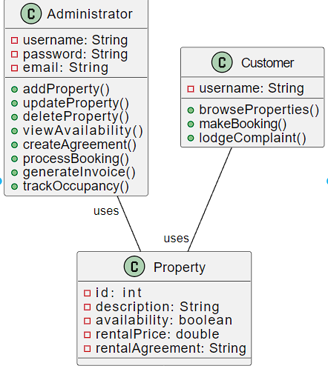  
fig 4.1 Class Diagram

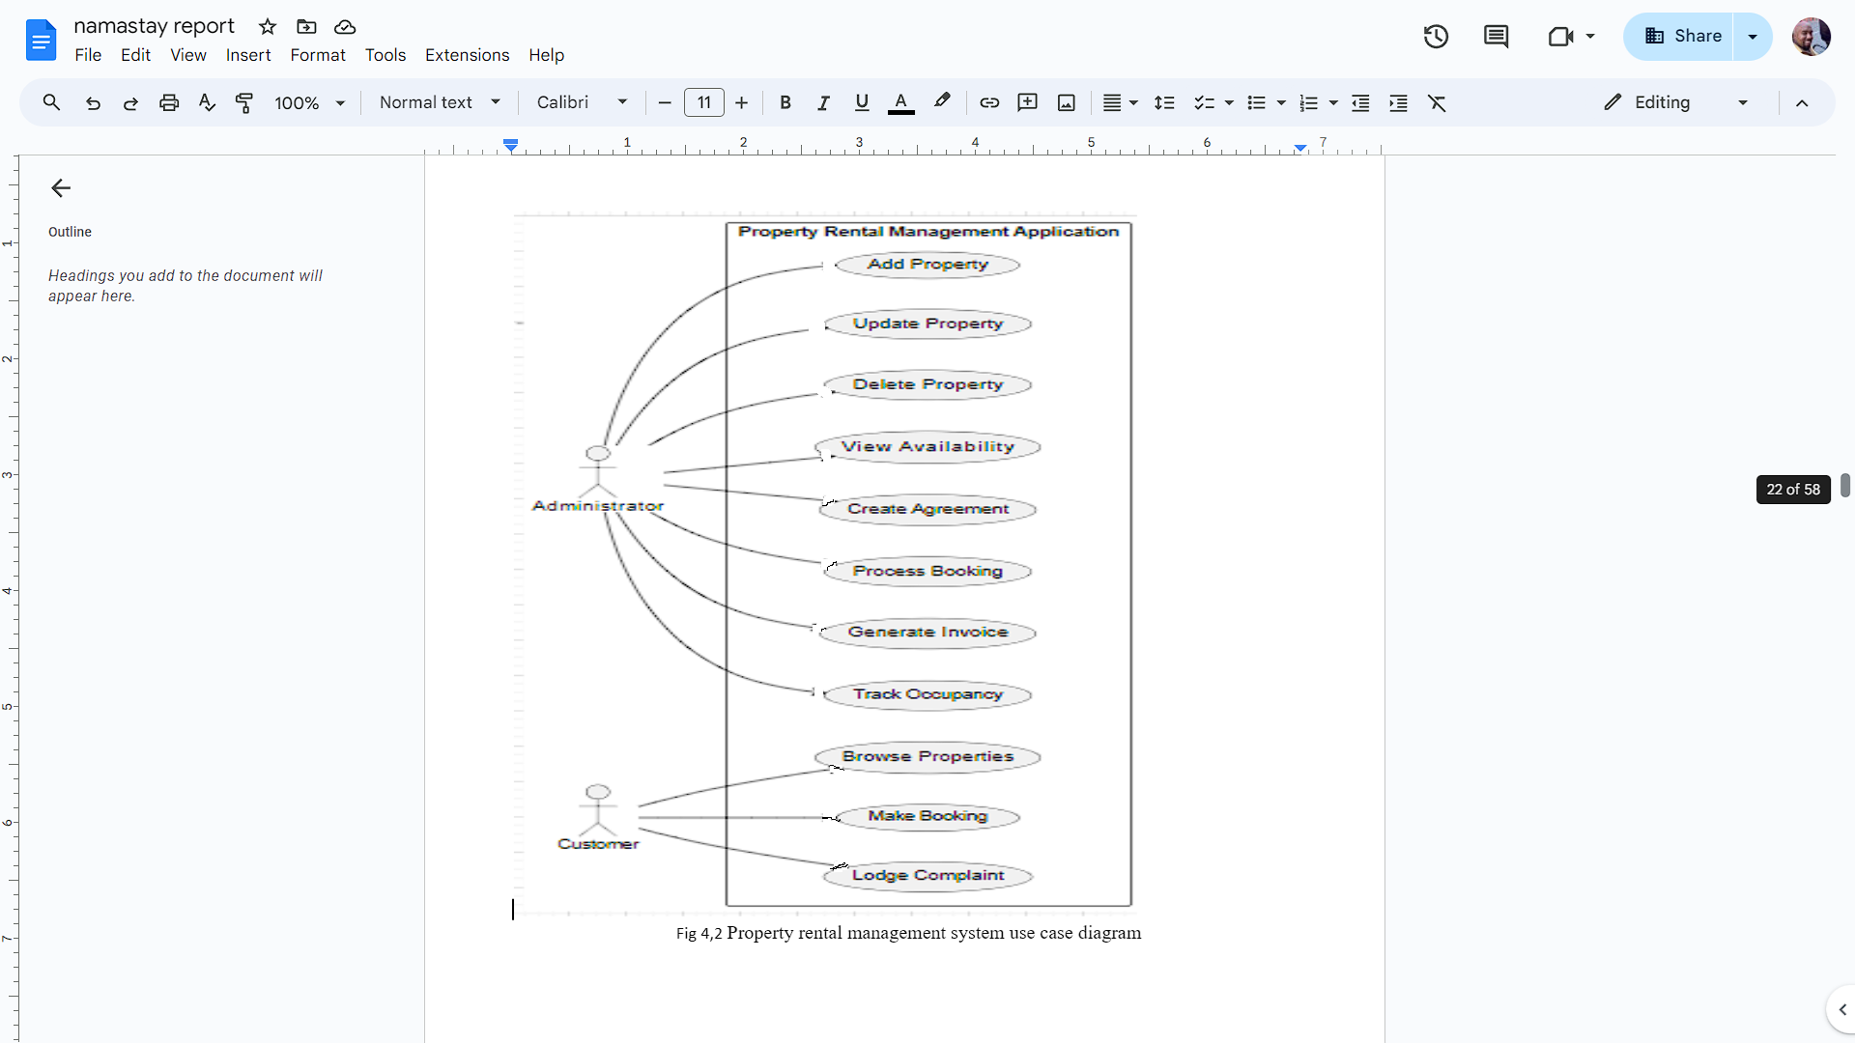

Fig 4,2 Property rental management system use case diagram

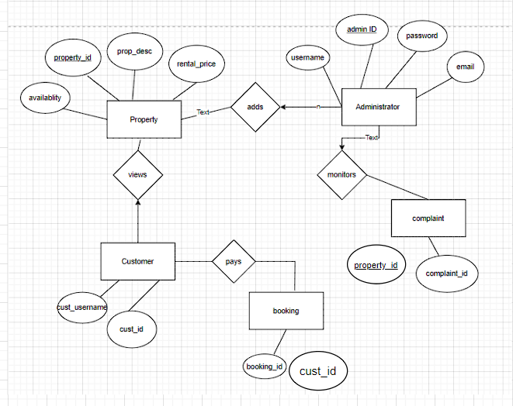

Fig 4.3 Database design

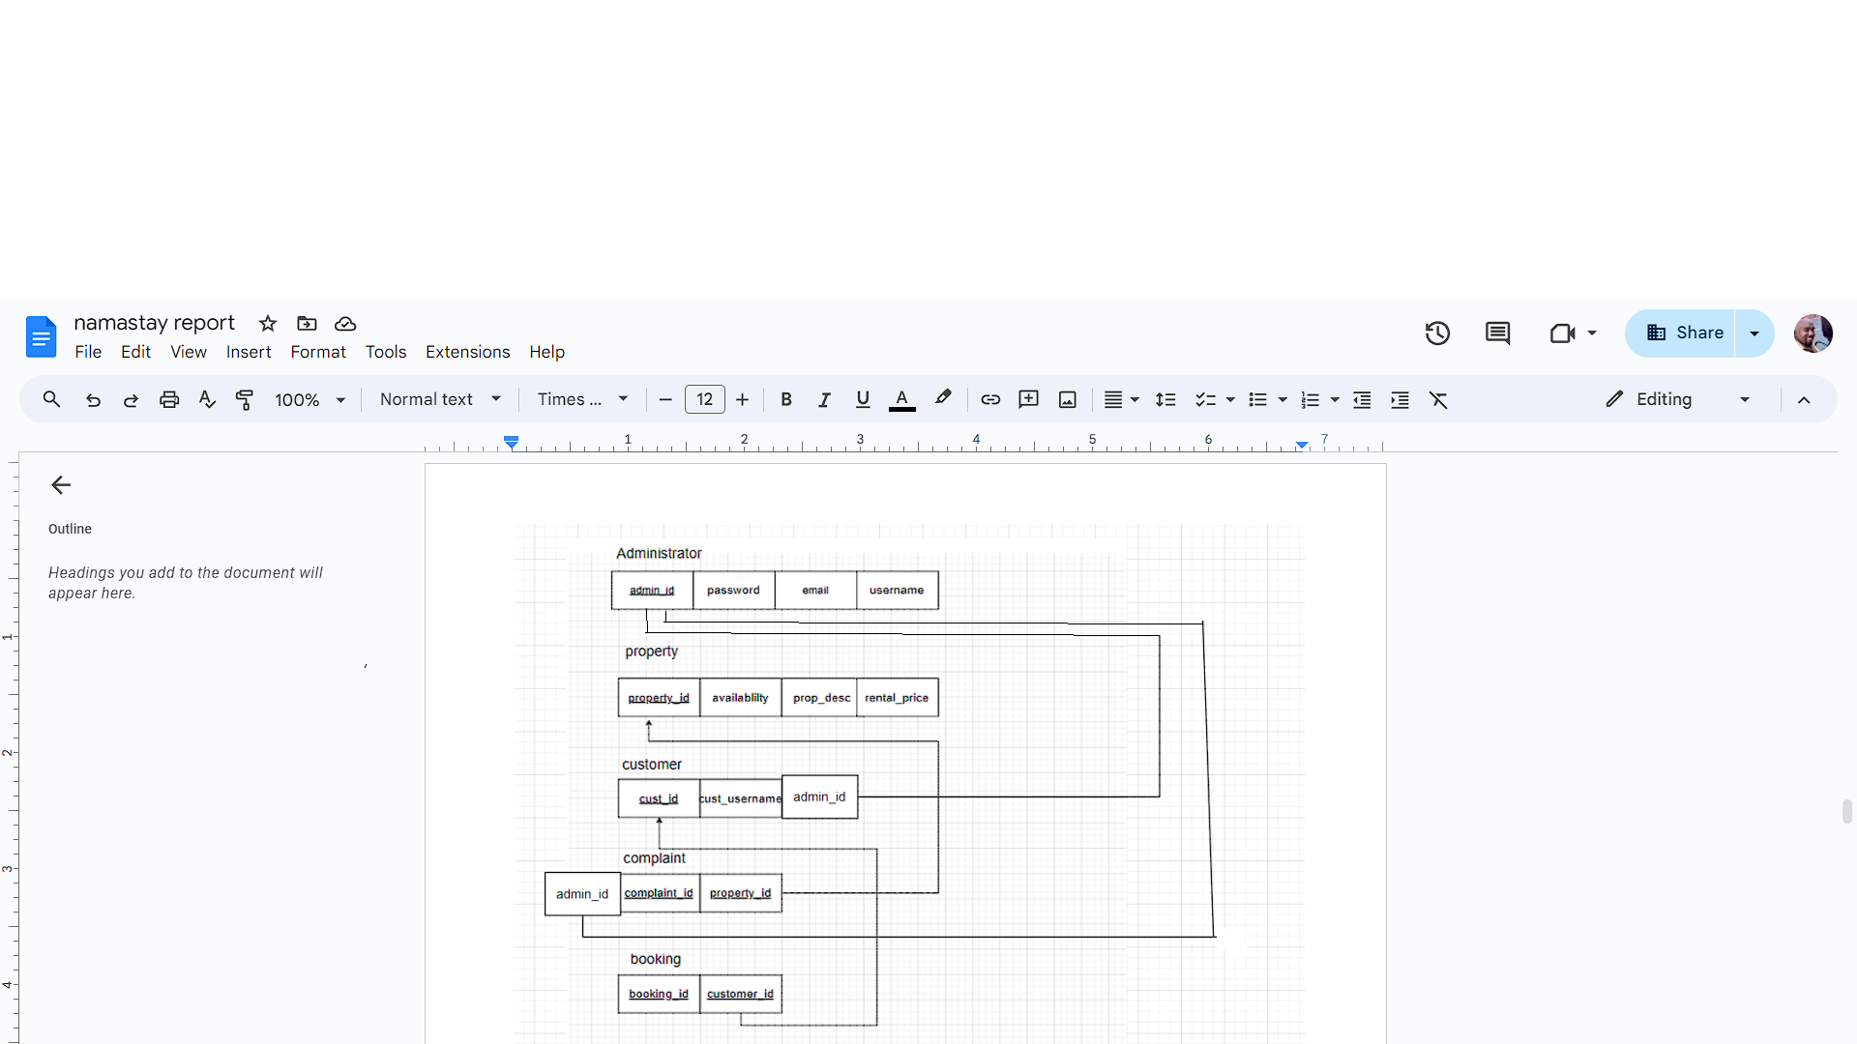

Fig 4.4 ER-schema

Wireframe/mockups  
  
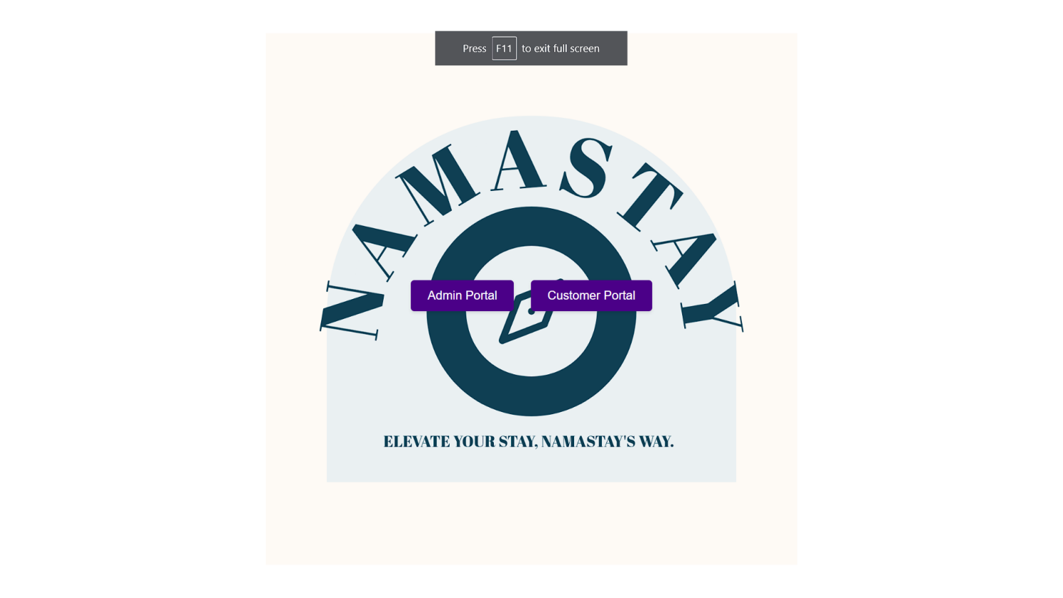  
 fig4.5.1main.html

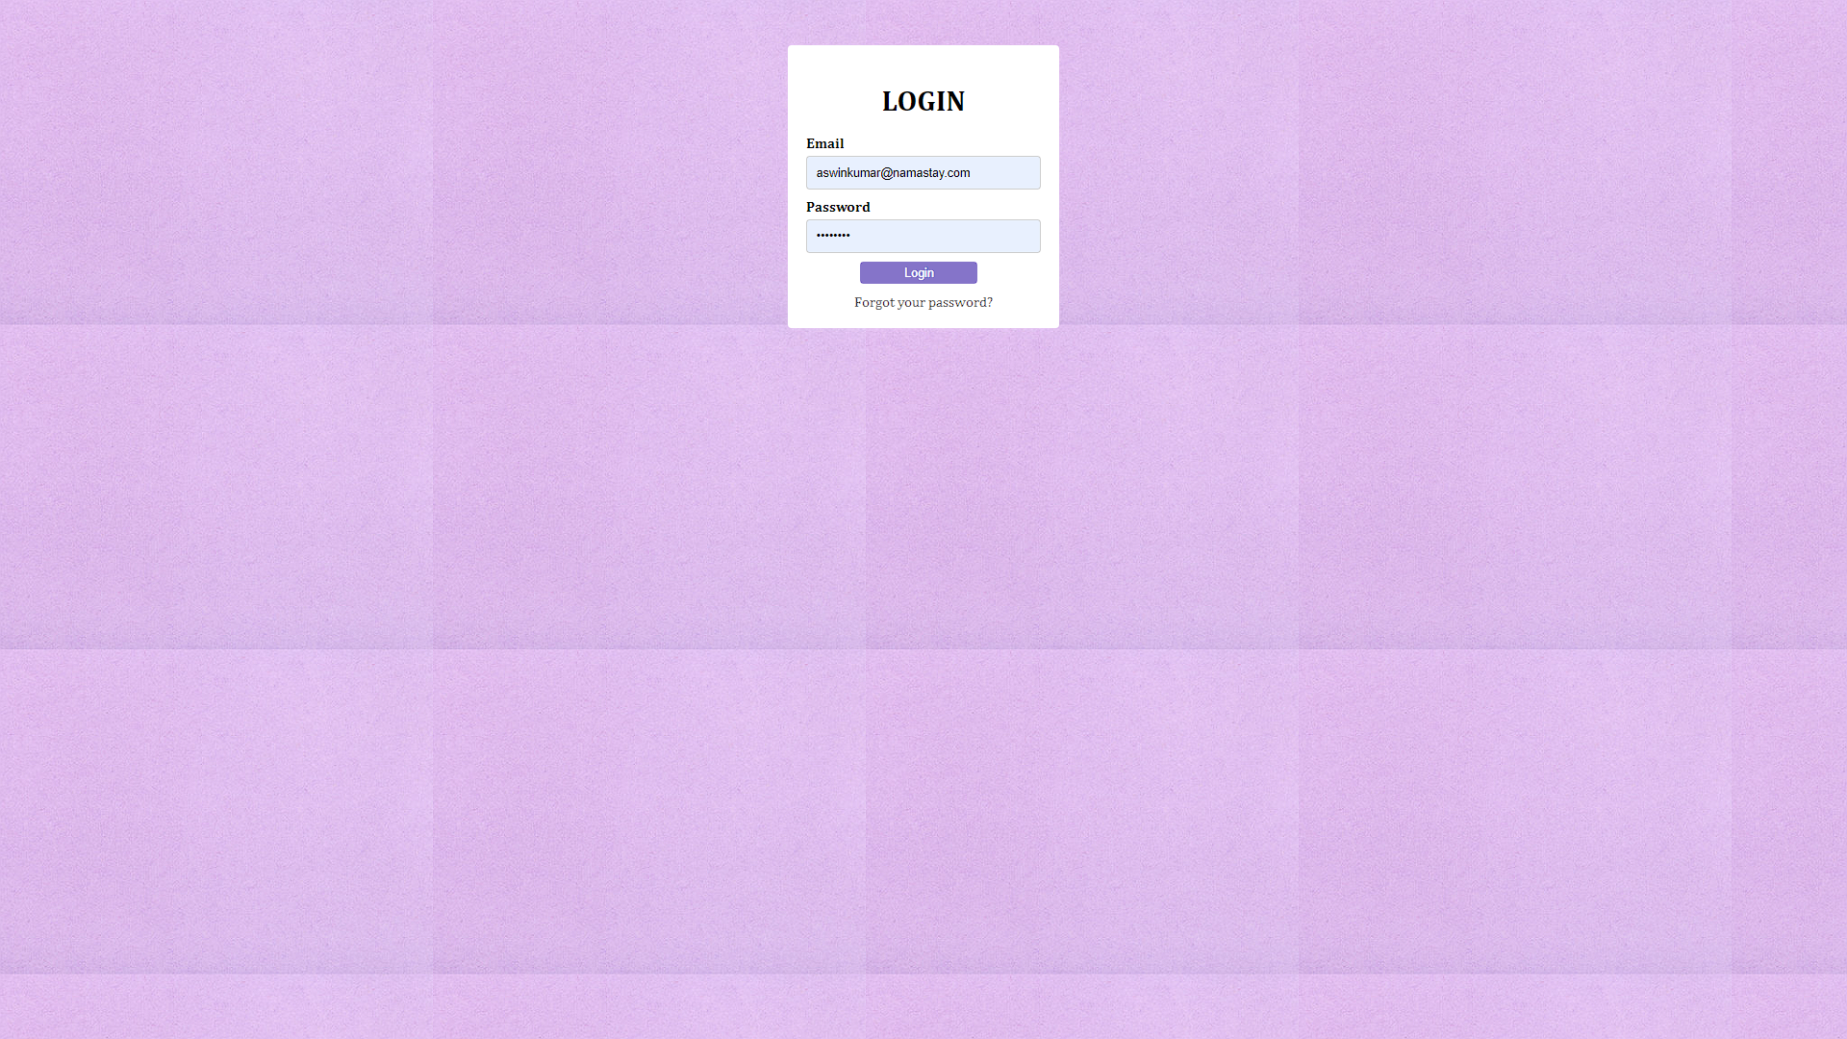  
  
 fig4.5.2admin-login.html  
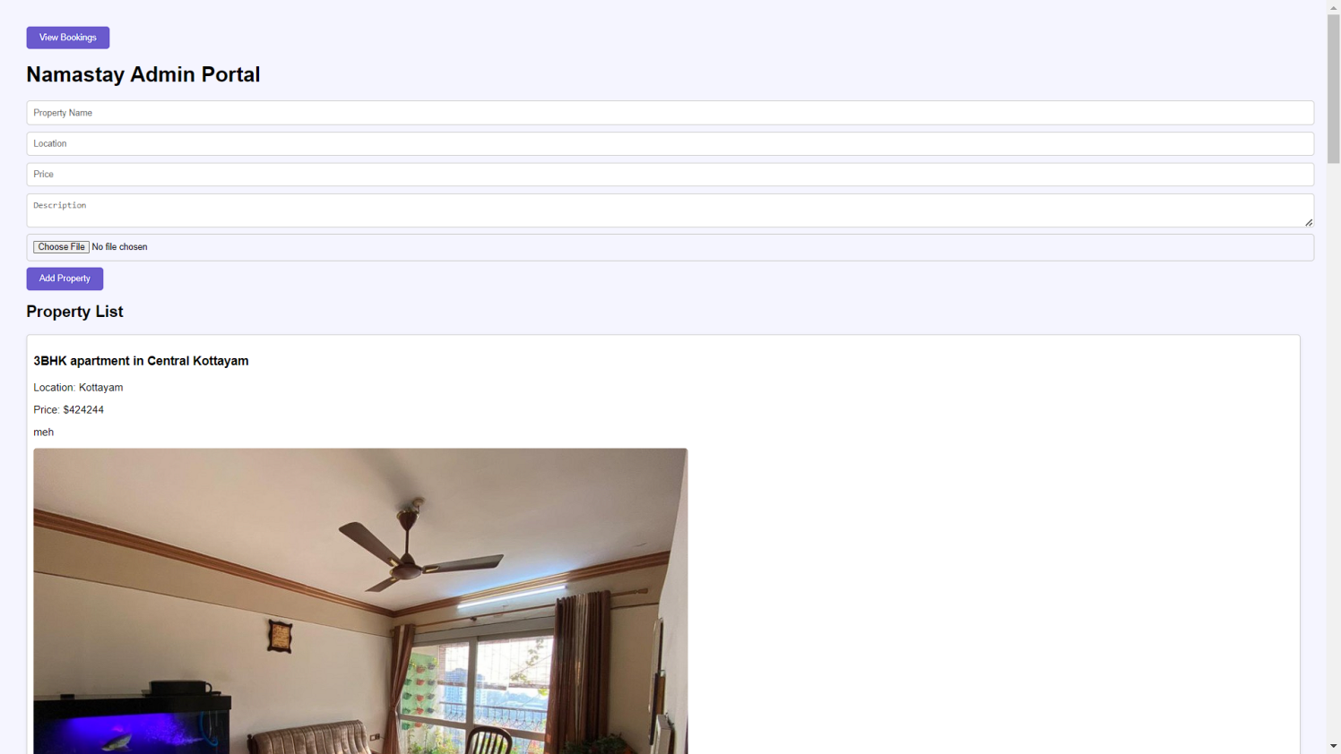

Fig 4.5.3 admin-home.html

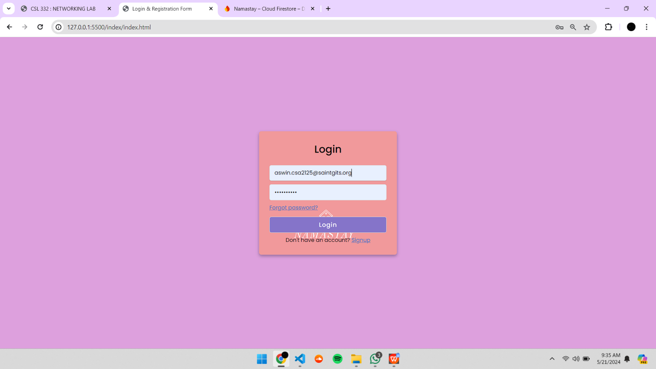

Fig 4.5.4 cust-home.html

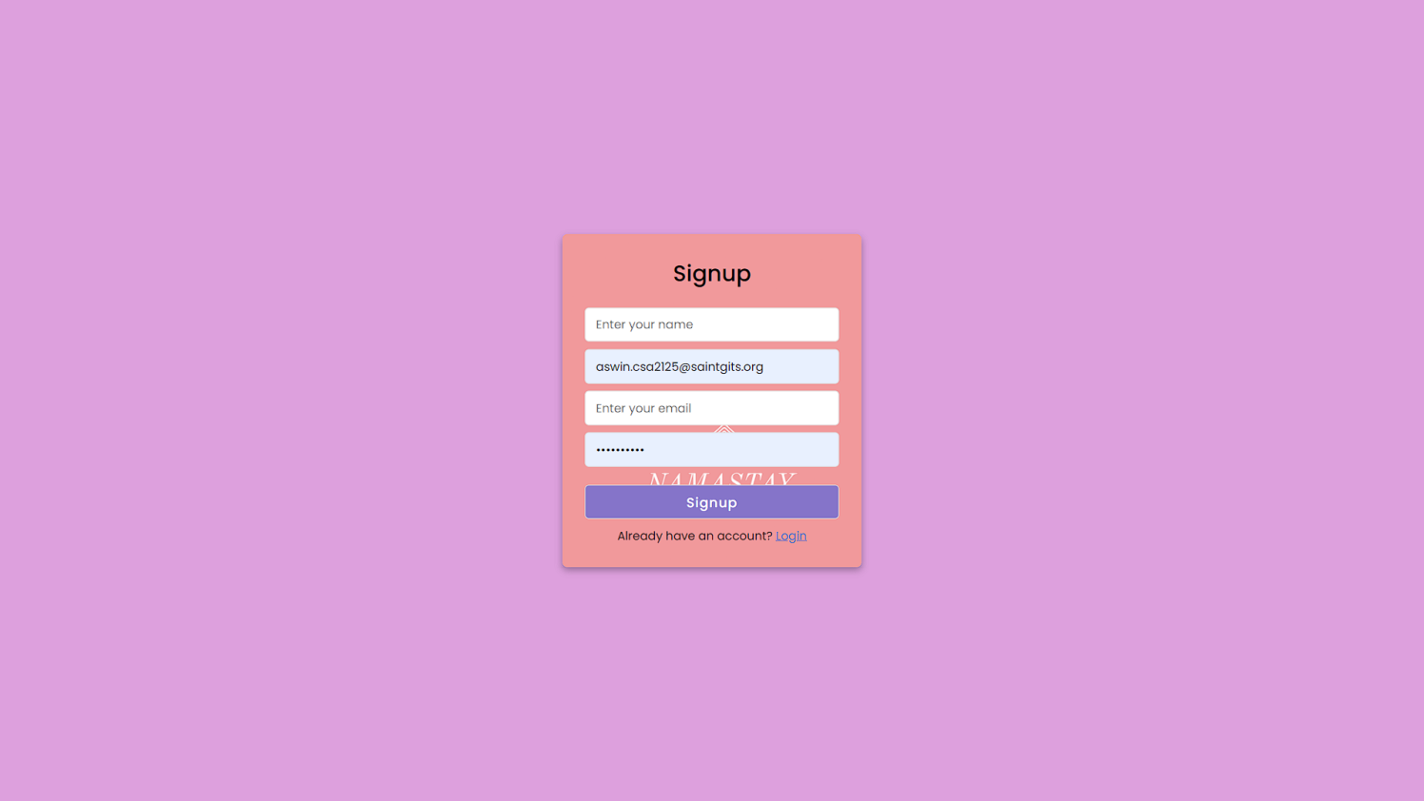  
  
  
 Fig 4.5.5 cust-home.html

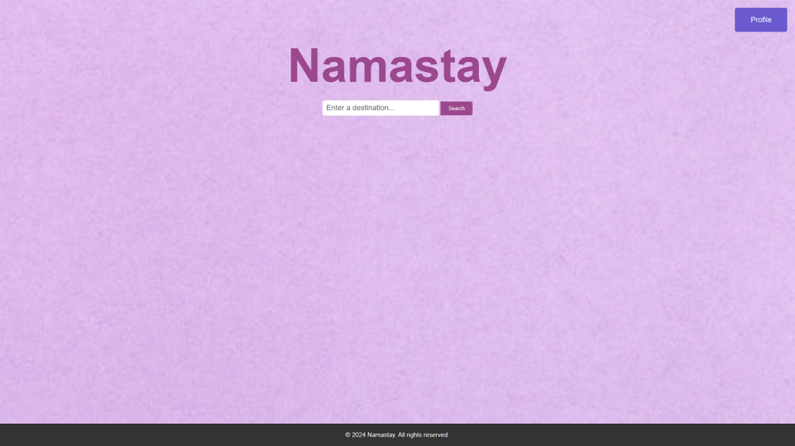

Fig 4.5.6 index.html

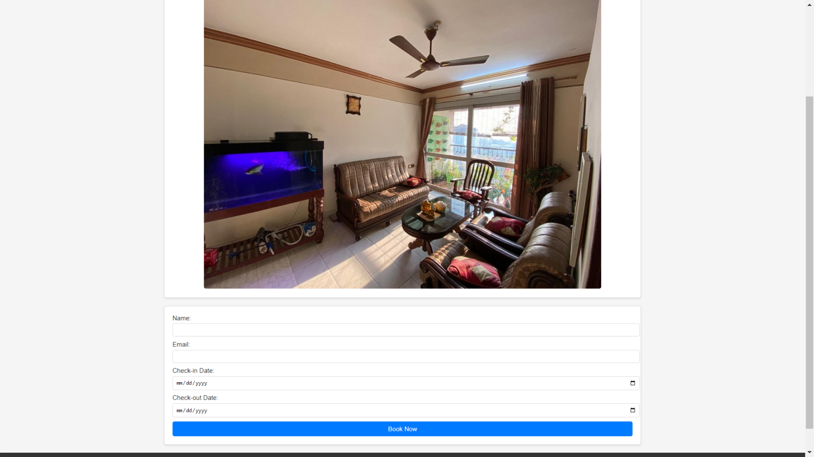

Fig 4.5.7 proplisting.html

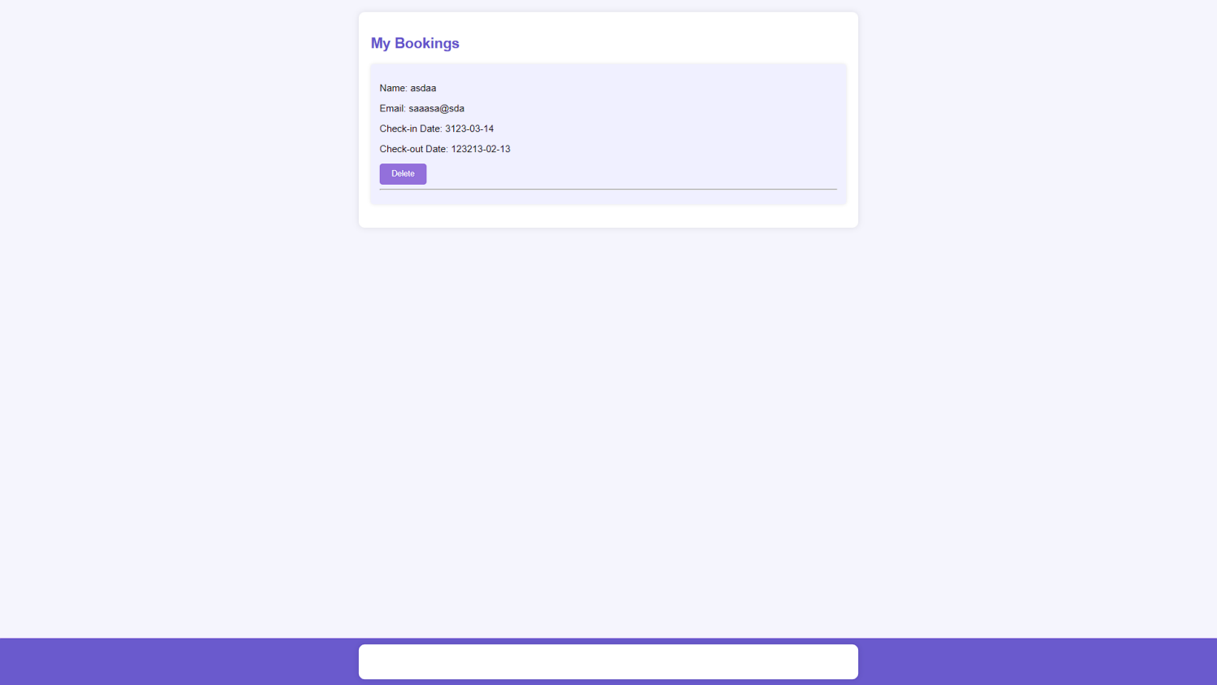

Fig 4.5.8 prrofile-dashboard.html

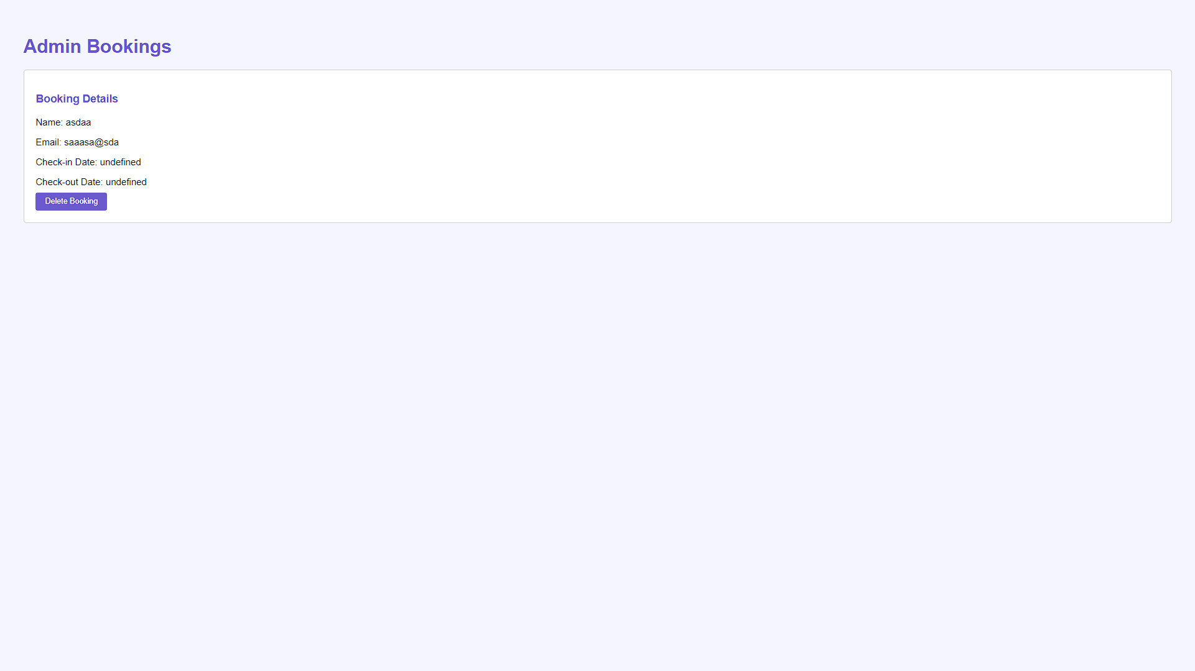\

Fig 4.5.9 admin-bookings.html

The Namastay is a web-based application with mobile support designed to facilitate property listings, tenant management, lease management, rent collection, maintenance tracking, and communication between stakeholders. The system will be deployed on a cloud infrastructure to ensure scalability and high availability.

**4.1 System Architecture**

The Namastay architecture follows a multi-tier architecture consisting of the following **layers:**   
Presentation Layer: User interfaces for web and mobile applications  
Application Layer: Business logic and service layer.

Data Layer: Data storage and management.

**4.2 Deployment Architecture**

The deployment architecture will leverage cloud services for hosting and scalability. Key components include:

Web Server: Hosts the web application and API endpoints.

Application Server: Runs business logic and background processes. Database Server: Manages relational database storage.

File Storage: Handles storage for documents, images, and videos.

servers. CDN (Content Delivery Network): Ensures fast content delivery.

**Component Design**

**4.3 Presentation Layer**

Web Application:

Developed using HTML5, CSS3, and JavaScript frameworks such as React or Angular. Provides user interfaces for property managers, landlords, and tenants. Mobile Application:

Developed using Flutter or React Native for cross-platform support (iOS and Android). Offers similar functionalities as the web application, optimized for mobile devices.

**CHAPTER 5**

**DEVELOPMENT**

**Tools and Technologies**

**Programming Languages**Frontend: HTML,CSS   
Backend: Node.js , Javascript   
**5.2 Databases**  
Firebase  
**5.3 Development Tools**IDE: Visual Studio Code   
Version Control: Git with GitHub or GitLab   
Testing: Jest (JavaScript), PyTest (Python), Selenium for end-to-end testing **Development Phases   
5.4 Requirements Analysis**

* Gather detailed requirements from stakeholders.
* Create user stories and acceptance criteria.
* Develop a detailed project plan and timeline.
  1. **5.5 System Design**

Architectural Design: Define the overall system architecture, including data flow diagrams and system components.

Database Design: Create an ERD (Entity-Relationship Diagram) and design database schema. API Design: Define RESTful API endpoints and document them using Swagger or Postman.

**5.6 Implementation**

**5.6.1 Frontend Development**

User Interface Development:

Develop wireframes and UI mockups.

Implement responsive design using HTML, CSS, and JavaScript frameworks. **5.8.2 Backend Development**

API Development:

Develop RESTful APIs to handle CRUD operations for properties, tenants, leases, payments, and maintenance requests.

Implement authentication and authorization using JWT (JSON Web Tokens). Business Logic:

Implement core business logic for property management, tenant screening, lease management, and rent collection.

Database Integration:

Integrate with PostgreSQL or MySQL using ORM (Object-Relational Mapping) tools.

**CHAPTER 6**

**TESTING AND MAINTENANCE**

**T**his document provides a detailed report on the testing and maintenance activities conducted for the Property Rental Management System (PRMS). This system is designed to manage rental properties, including tenant management, lease tracking, maintenance requests, and financial transactions. Effective testing and maintenance are crucial to ensure the system's reliability, security, and performance.

1. **Testing Procedures**

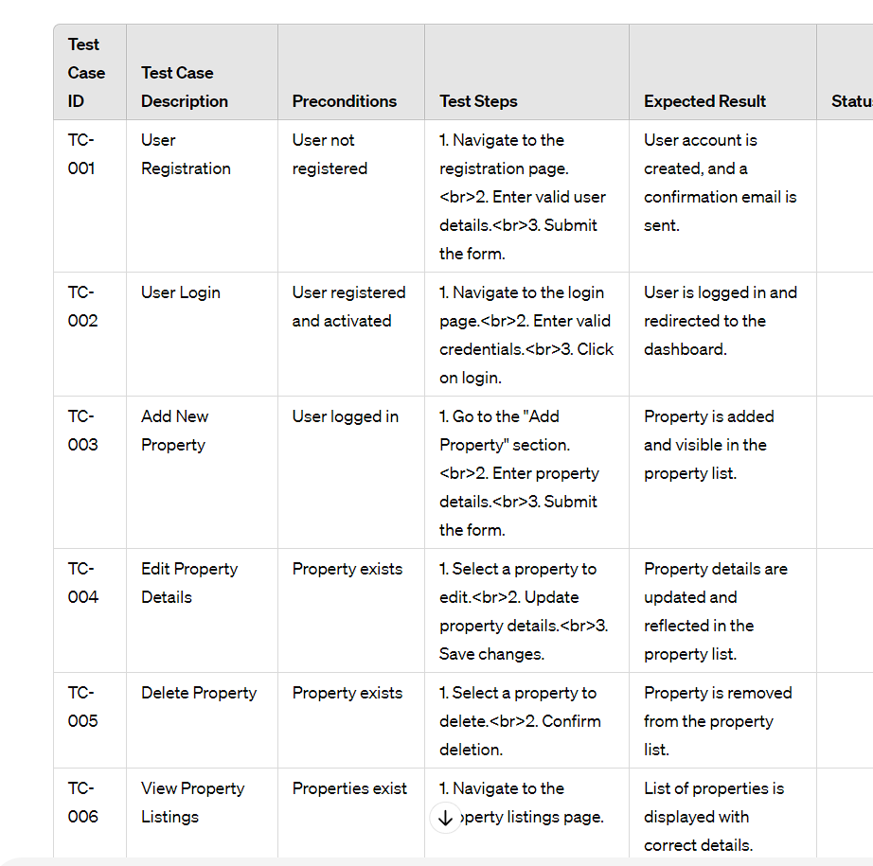

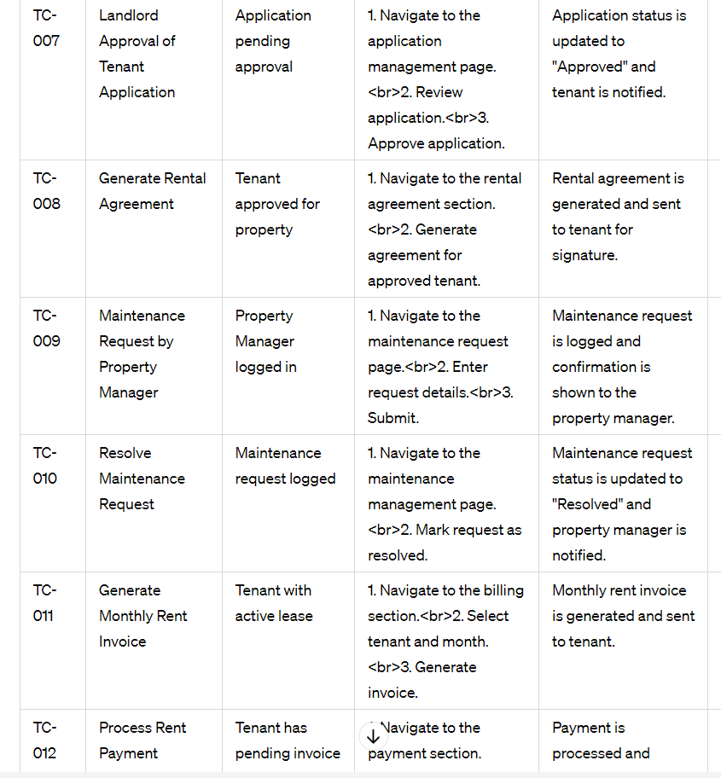

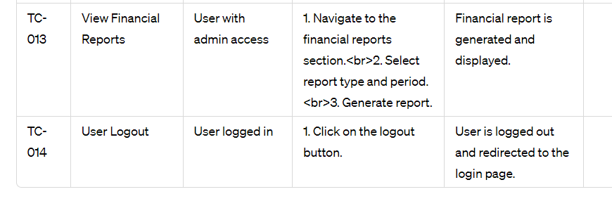

**6.1 Types of Testing Conducted**

**6.2 Unit Testing**

Objective: Validate the functionality of individual components or units.

Tools Used: JUnit, NUnit

Frequency: During the development phase for each module.

**6.3 Integration Testing**

Objective: Verify the interactions between integrated modules.

Tools Used: Postman (API testing), Selenium (web interface testing)

Frequency: After unit testing of related modules is completed.

**6.4 System Testing**

Objective: Ensure the entire system functions correctly.

Tools Used: Selenium, JMeter (performance testing)

Frequency: Before deployment to a staging environment.

**6.5 User Acceptance Testing (UAT)**

Objective: Validate the system's functionality from an end-user perspective.

Tools Used: Feedback forms, user scenarios

Frequency: Prior to final deployment.

**6.6 Regression Testing**

Objective: Confirm that new code changes do not adversely affect existing functionalities.

Tools Used: Selenium, TestNG

Frequency: After every major update or bug fix.

**6.7 Performance Testing**

Objective: Evaluate the system's performance under load.

Tools Used: JMeter, LoadRunner

Frequency: During system testing and periodically post-deployment.

**6.8 Security Testing**

Objective: Identify vulnerabilities and ensure data protection.

Tools Used: OWASP ZAP, Burp Suite

Frequency: During system testing and regularly as part of maintenance.

**6.9 Test Cases and Results**

Test Type, Total Cases, Passed, Failed, Remarks

Unit Testing, 150, 145, 5, Issues addressed and re-tested

Integration Testing, 75, 70, 5, Fixed and re-tested

System Testing, 100, 95, 5, Resolved

UAT, 50, 48, 2, Adjustments made based on feedback

Regression Testing, 120, 115, 5, Re-tested after fixes

Performance Testing, 3 (scenarios), 3, 0, Met performance criteria

Security Testing, N/A, N/A, 4, All vulnerabilities fixed

**6.10 Maintenance Procedures**

**6.11 Regular Maintenance Activities**

**6.12 Backup and Recovery**

Frequency: Daily backups, weekly recovery tests.

Details: Daily backups of the database and critical files; weekly tests to ensure backup integrity and recoverability.

**6.13 Security Patching**

Frequency: Monthly updates, immediate for critical patches.

Details: Monthly application of security patches; immediate patching for any critical vulnerabilities identified.

**6.14 Performance Monitoring**

Frequency: Continuous monitoring, monthly reviews.

Details: Continuous performance monitoring with automated tools; monthly reviews to identify and address performance issues.

**6.15 Bug Fixes**

Frequency: As needed.

Details: Immediate attention to critical bugs; monthly review and resolution of less critical issues. **6.16 Feature Updates**

Frequency: Quarterly.

Details: Quarterly updates incorporating new features based on user feedback and market trends. **6.17 Maintenance Schedule**

Activity, Frequency, Responsible Team

Backup, Daily, IT Operations

Backup Recovery Test, Weekly, IT Operations

Security Patching, Monthly, Security Team

Performance Review, Monthly, DevOps Team

Bug Fixes, As needed, Development Team

Feature Updates, Quarterly, Product Team

**6.18 Incident Management**

Incident Reporting: Users report issues via a dedicated support portal.

Incident Response: Immediate acknowledgment within 2 hours.

Resolution Time: Critical issues resolved within 24 hours; minor issues within 3 business days. 5.2 Tools and Technologies

JUnit, NUnit: Frameworks for unit testing.

Postman: Tool for API testing.

Selenium: Tool for automating web browsers, used for testing web applications. JMeter, LoadRunner: Tools for performance testing.

OWASP ZAP, Burp Suite: Tools for security testing.

**CHAPTER 7**

**CONCLUSION**

The Property Rental Management System (PRMS) project was initiated to address the various challenges faced by property managers, landlords, and tenants in the rental property market. The primary objectives were to streamline property management operations, enhance communication between stakeholders, improve financial management, and provide an overall better user experience. This system integrates multiple functionalities, including property listings, tenant management, lease management, rent collection, maintenance tracking, and communication modules, within a cohesive, user-friendly platform.

The successful development and deployment of the Property Rental Management System mark a significant milestone in enhancing the efficiency and effectiveness of property management operations. The system’s robust functionalities, combined with its user-friendly design and scalability, position it as a valuable tool for property managers, landlords, and tenants. By addressing key challenges and incorporating user feedback, the PRMS is well-equipped to adapt to future needs and technological advancements, ensuring its relevance and utility in the evolving property rental market.

The project team expresses gratitude to all stakeholders for their support and collaboration throughout the development process. The commitment to continuous improvement and innovation will drive the future success of the Property Rental Management System, delivering sustained value to its users.

**CHAPTER 8**REFERENCES

* <https://airbnb.com>
* <https://firebase.com>
* <https://firestore.com>
* https://www.w3schools.com/html/default.asp
* <https://css-tricks.com/>
* <https://javascript.info/>
* https://getbootstrap.com/docs/
* https://api.jquery.com/
* https://reactjs.org/docs/getting-started.html
* https://nodejs.org/en/docs/
* https://expressjs.com/en/starter/installing.html
* <https://www.restapitutorial.com/>
* https://developers.google.com/maps/documentation

**CHAPTER 9**

**APPENDIX**

PROGRAM  
Main.html

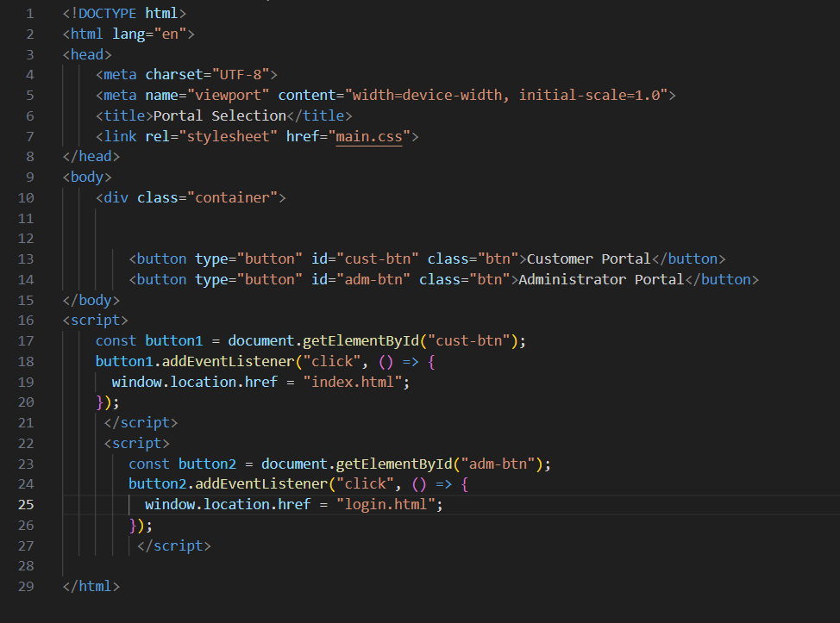

Login.html  
  
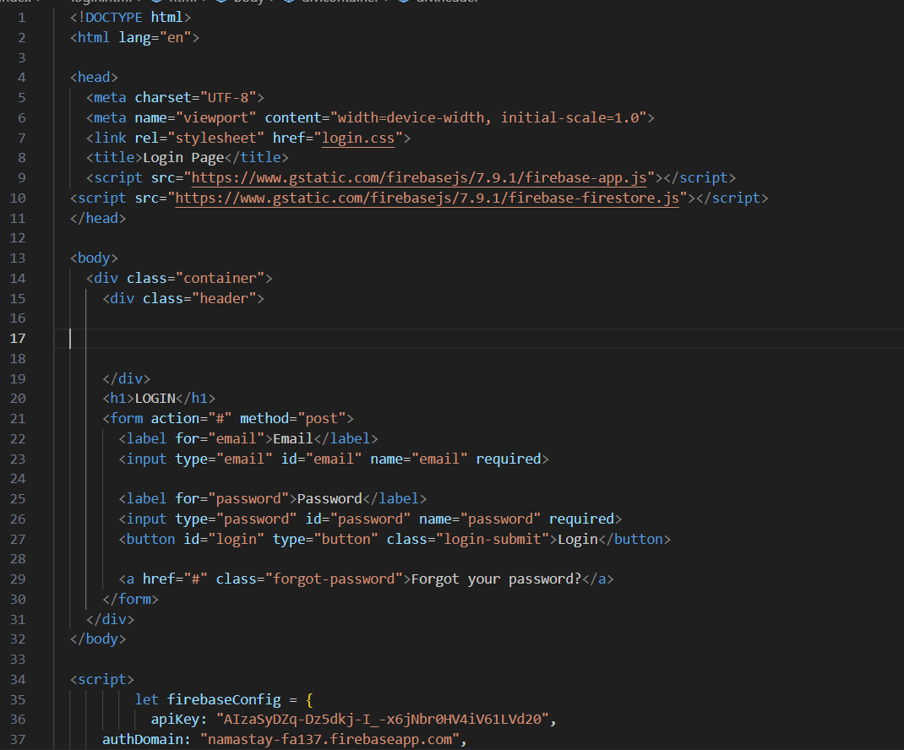  
  
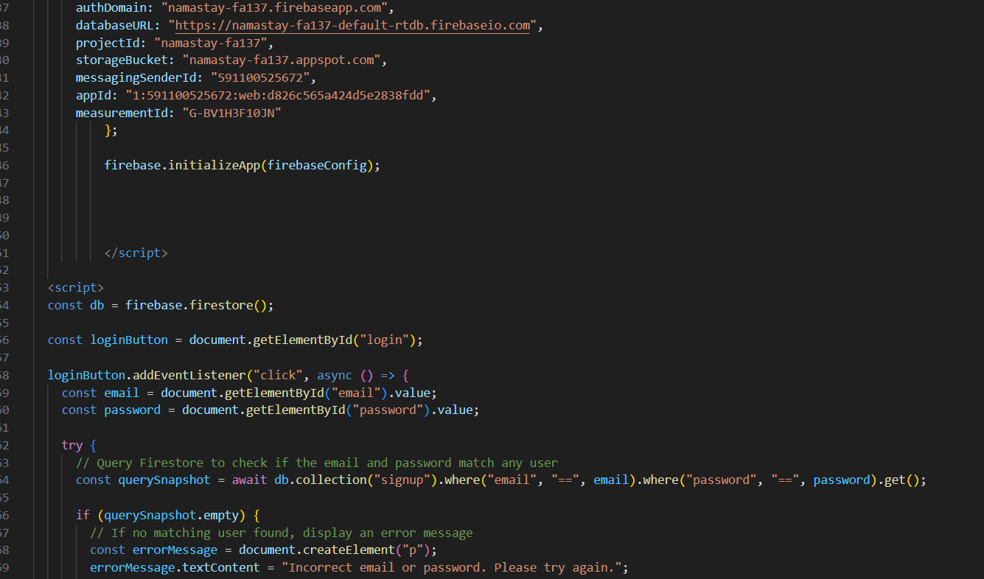  
  
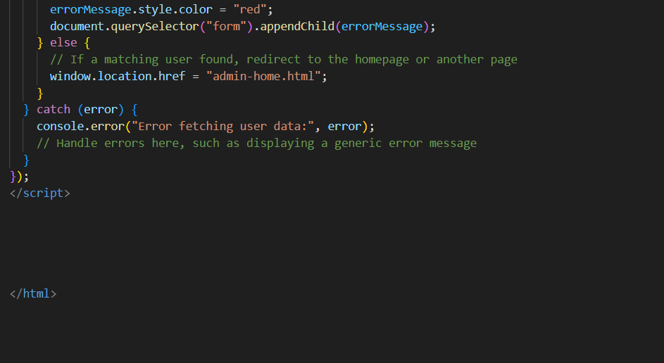  
  
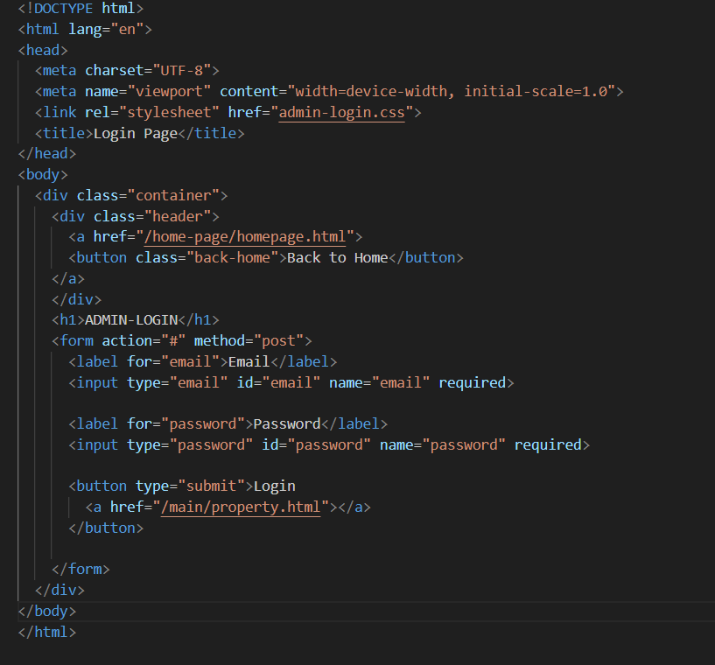  
  
loggedhomepage.html  
  
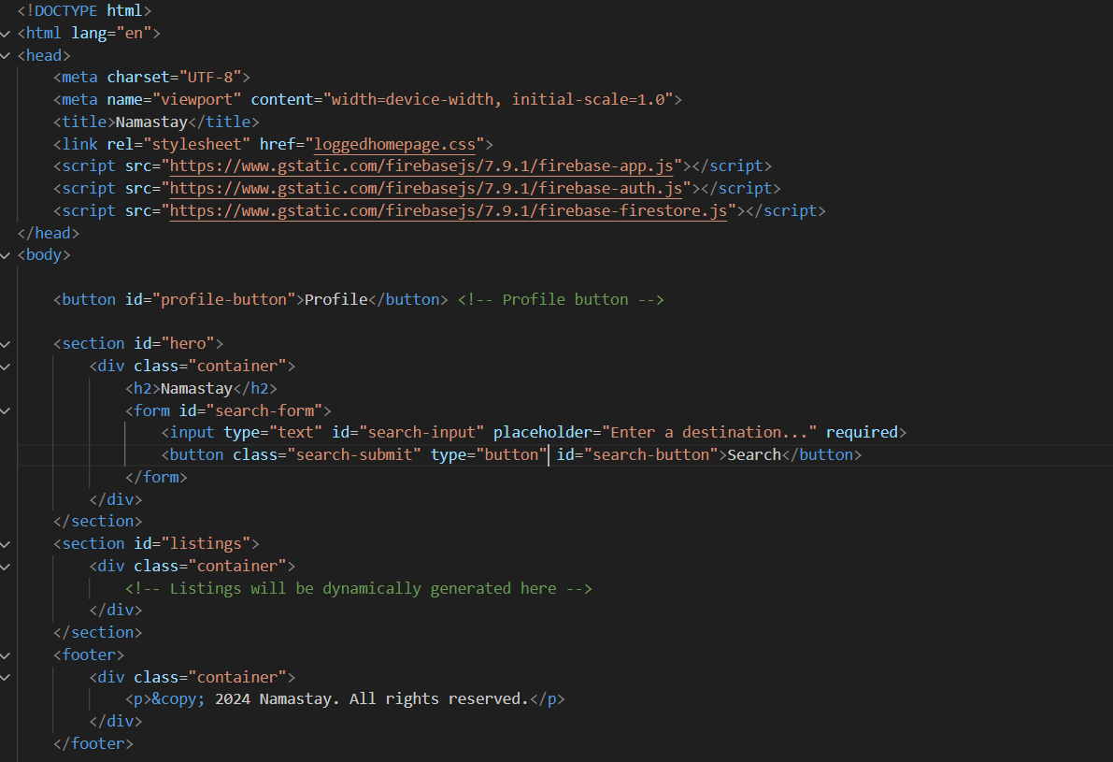  
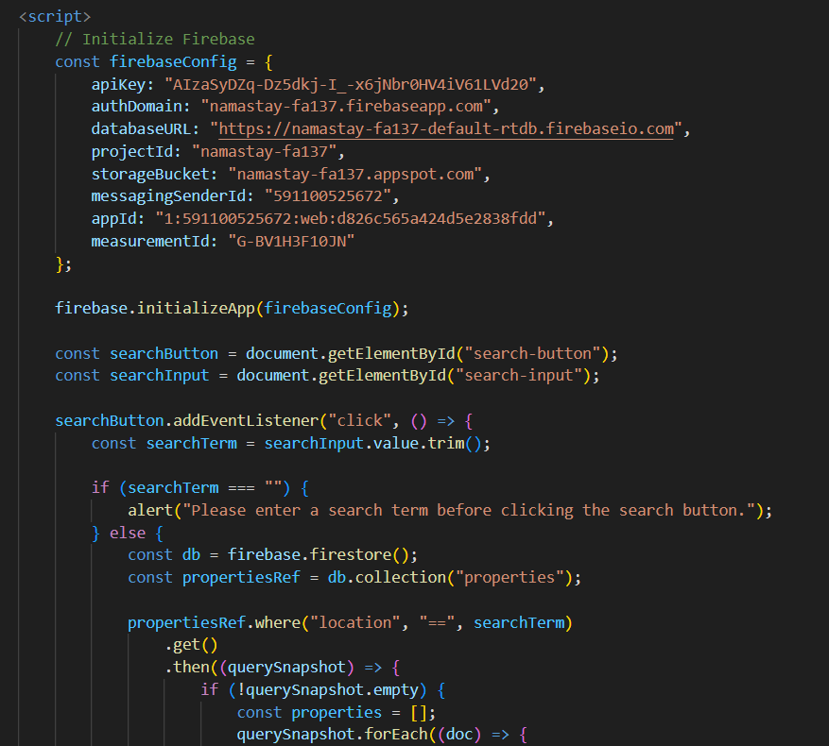  
  
  
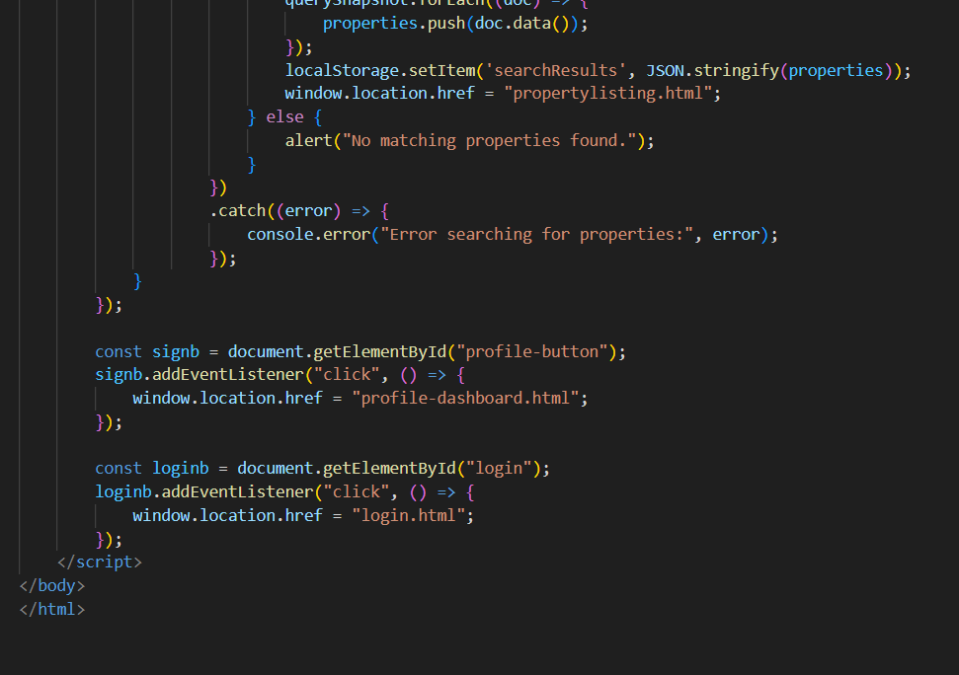

Admin-home.html  
  
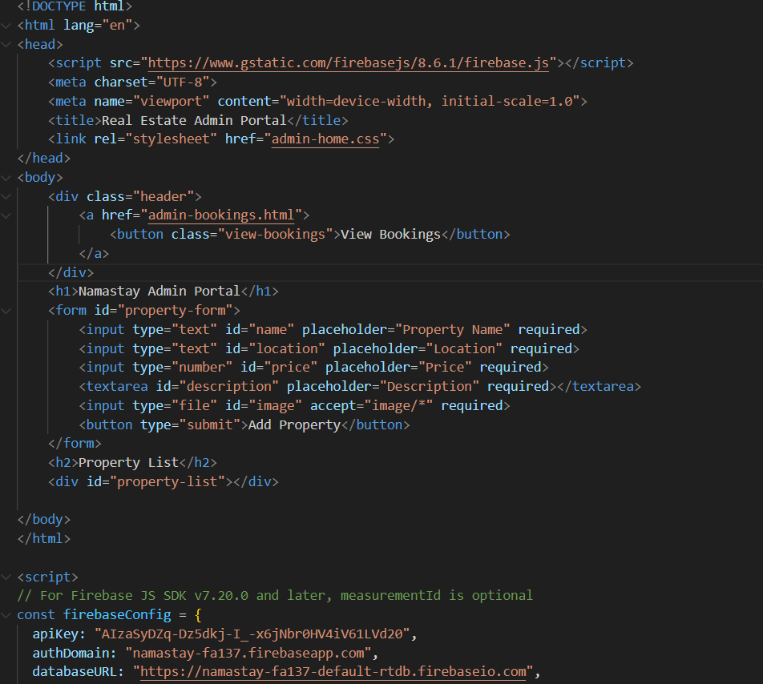  
  
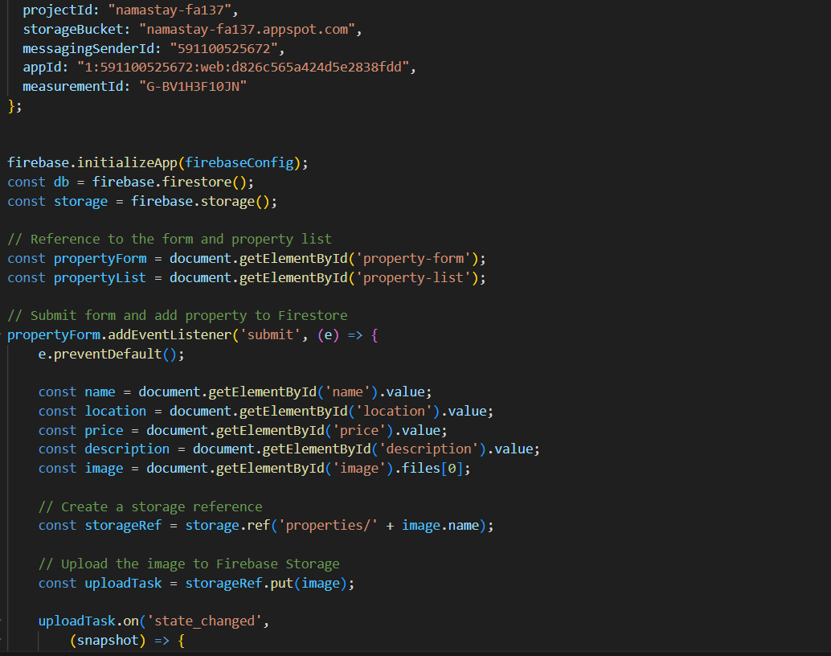  
  
  
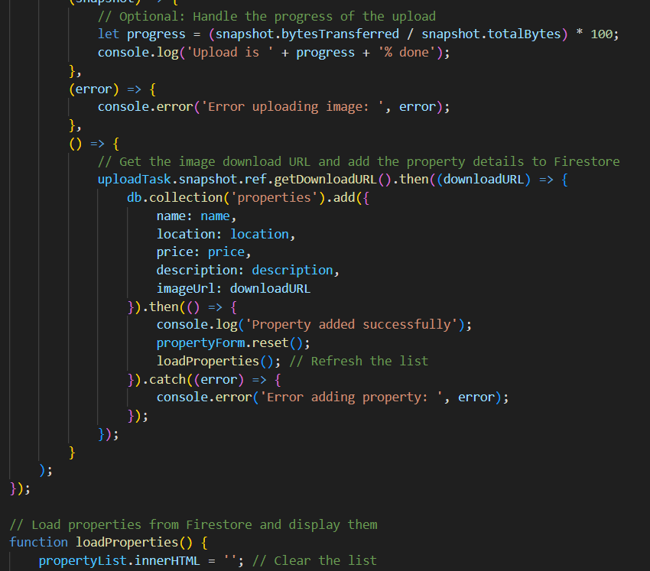  
  
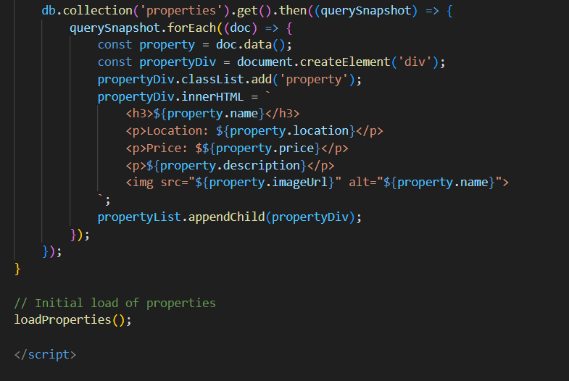

Admin-bookings.html  
  
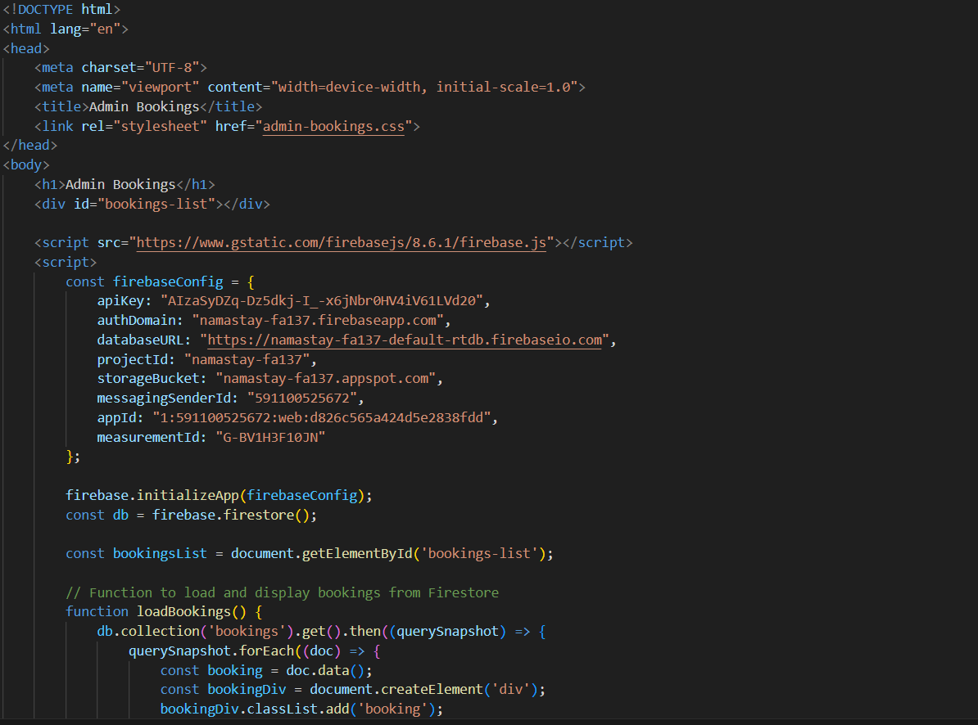  
  
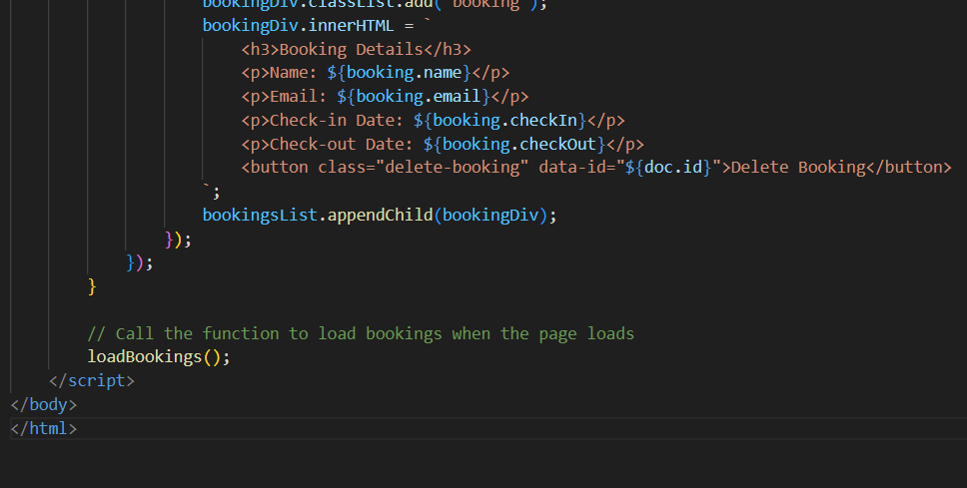

Index.html  
  
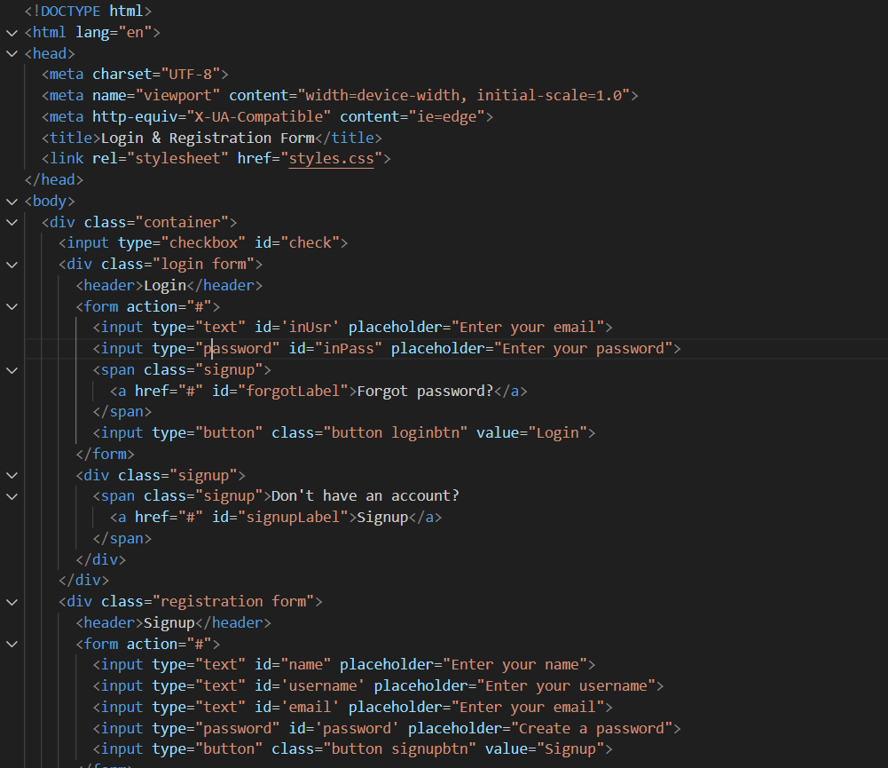  
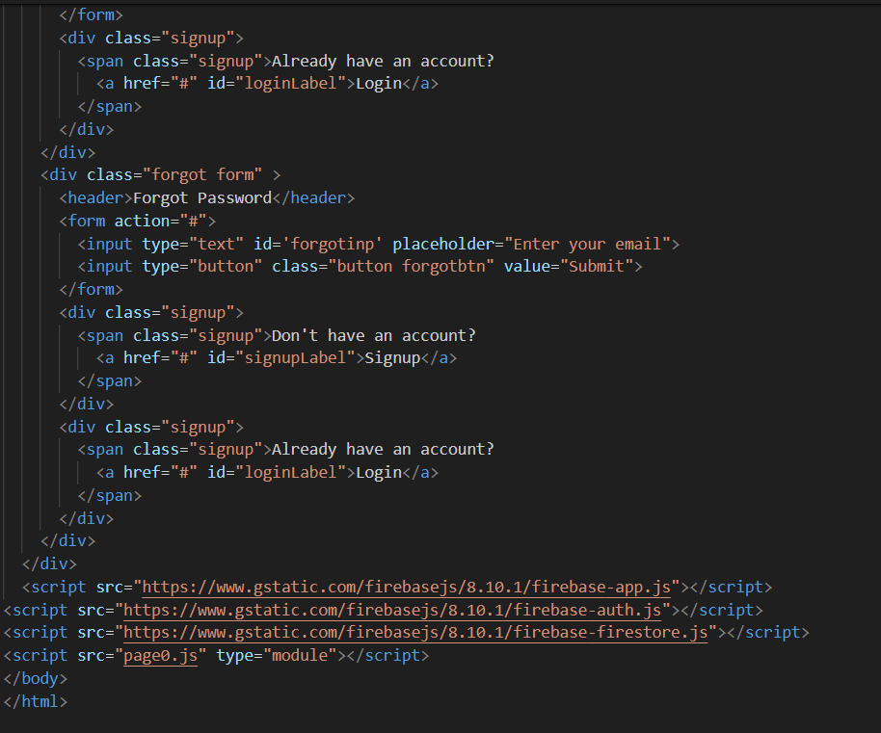

Propertylisting.html  
  
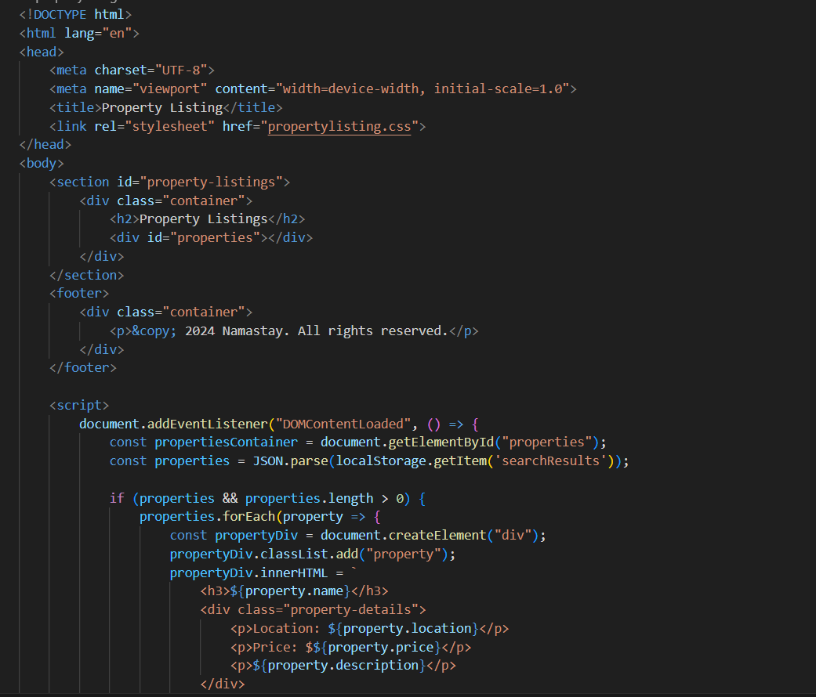  
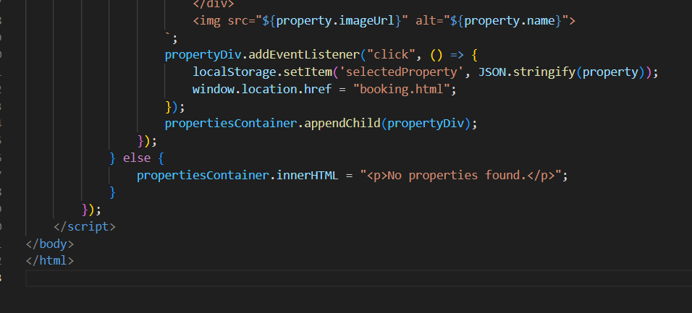

Profile-dashboard.html  
  
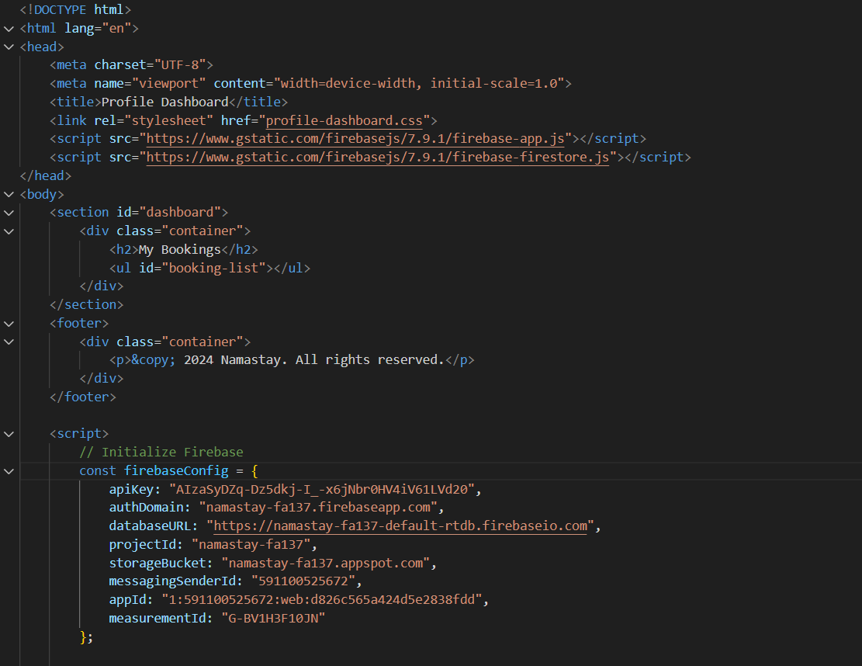  
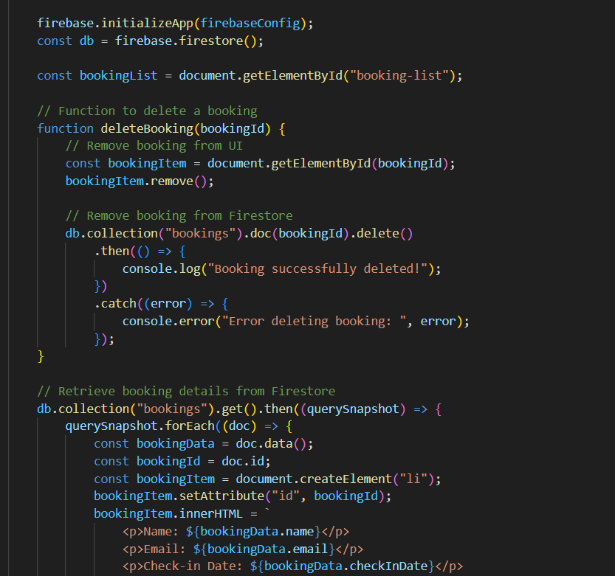  
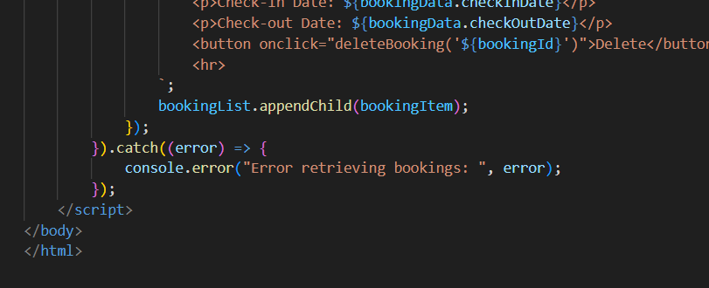

Firebase.js  
  
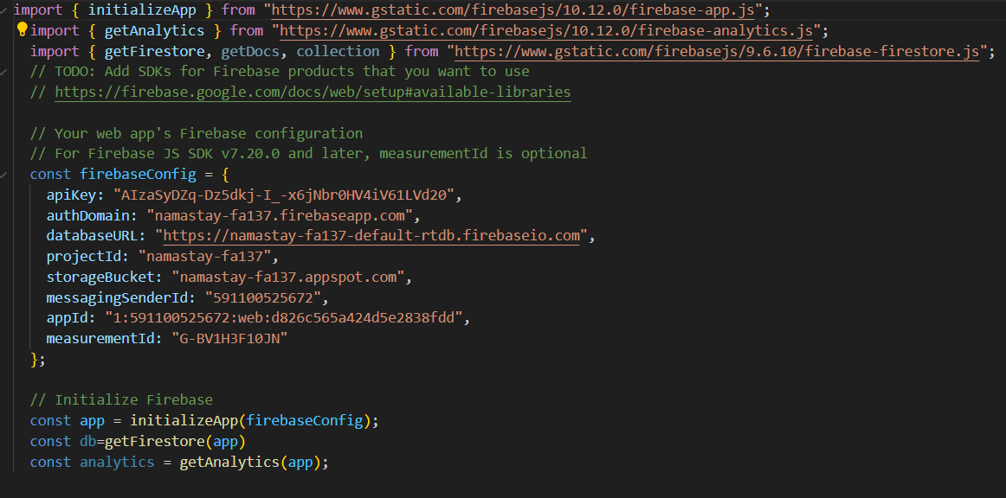  
  
config.js  
